Ella Baker Elementary

Family Handbook 2022-2023
Table of Contents
Ella Baker Welcome and School Info |  | Pg. 4 - 19
- Welcome & Vision & Mission of Ella Baker
- Baker Eight Traits and Service Learning
- Ella Baker Staff & Who To Contact Sheet
- Ella Baker PTSA School Calendar
- Daily Bell Schedule
- PTSA Contacts
Ella Baker Procedures/Guidelines: |  | Pg. 20-36
- Communication, Conference Weeks
- Library Policy,
- Safe Arrival, Dismissal, Attendance Procedures
- Parking Lot Safety, Drop off and Pick up Map
- Health Room/Medication, Illness and Injury
- Vacations and Pre-Arranged Absence Form
- Child Find, Classroom Parties
- Parent Visitation, Volunteer Guidelines
- Lunch Information
- School Emergency Information and Procedures
- Homework Policy and Responsibilities
Ella Baker Student Expectations: |  | Pg. 37-44
- Student Expectations
- Playground Policy
- Ella Baker Elementary “Making It Right Plan”
- Ella Baker Elementary Behavior Contract

- Bicycles/Skateboards/Scooters
- Safety Patrol/Dress Code/Lost and Found
- Personal Electronics, Communication Guidelines
Lake Washington School District Information: |  | Pg. 44 – 68
- Mission/Vision/Student Profile
- 2021-2022 Student Rights & Responsibilities
- Introduction
- Attendance
- Discipline Process
- Codes of Conduct
- Prohibition of Discrimination and Harassment
- Prohibited Items
- Other Policies

Welcome

Welcome to Ella Baker Elementary!

We are excited to work with you and your child. At Ella Baker, our mission is to empower changemakers who know themselves, understand others and are inspired to make an impact on our world. Our vision is to inspire students to embrace their talents and passions in order to help them realize their potential, become global citizens and changemakers, and develop the academic and social skills that will make the world a better place.

This family handbook provides answers to the most important questions about life at Ella Baker Elementary. It also contains many LWSD policies.
Our hope is that this handbook will provide answers to most of your questions, but if you are looking for more information, please contact your teachers, school principal, or office staff.

About Ella Baker Elementary

Mission and Vision
Mission: Empowering changemakers who know themselves, understand others and are inspired to make an impact on our world.

Vision: Inspiring students to embrace their talents and passions within them in order to realize their potential, become global citizens and changemakers, and develop the academic and social skills that will make the world a better place.

Inspire. Empower. Impact.

Content. Collaboration. Communication. Citizenship. Character. Critical and Innovative Thinker
The Baker Eight Traits

Be Kind. Be Brave. Be You. Be the Change
Our Values | We value relationships and connections  All student strengths are celebrated, we recognize the importance of whole child development  We empower students to be changemakers and to have impact as a part of the larger community  We believe in equal emphasis on academic rigor and character development  Standards are taught in a purposeful and meaningful way and are accessible to a range of learners  We believe in lifelong learning for all, students and staff  We take risks, ask questions, use a growth mindset, and celebrate mistakes.  We are dedicated to the success of all students. Believe we, as teachers, have the power to impact students' lives.  Families have the right to take a meaningful part in their child's academic and social well-being.
Students’ Rights | Students have the right to love school and learning.  Students have the right to feel safe, cared for and respected by all.

Students have the right to be heard, to be unique, to guide their education and to express their feelings, ideas and opinions.
Students have the right to be themselves in a school that supports different learning styles, varied pacing, and personalization.
Students have the right to an environment that promotes, respects and celebrates diversity and promotes compassion, empathy, and equity.
Students have the right to pursue service learning opportunities.
Students have the right to build a trusting and supportive relationship with peers, adults and the community.
Mistakes are part of the learning process and we will celebrate and learn from them.
Students will be given opportunity to identify their own strengths and how they contribute to the community.
Students have the right to regularly collaborate and become empowered in our school.
Students have the right to be viewed as gifted and talented.
Students have the right to advocate for what they believe in, and in turn be advocated for.

History
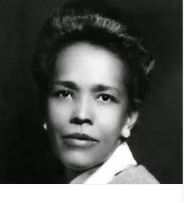
The journey of opening Ella Baker Elementary began in the Spring of 2017, when Principal, Kim Bilanko and teacher, Angie Angel presented their vision for a school to district leaders and then the official groundbreaking was on June 7th, 2017.

Ella Baker
We are thrilled to be named Ella Baker Elementary. Ella Baker was a brilliant Black hero of the civil rights Freedom Movement who inspired and guided emerging leaders such as Rosa Parks. Ella played a key role in some of the most influential organizations of all time, including the NAACP, Martin Luther King's Southern Christian Leadership Conference, and the Student Nonviolent Coordinating Committee. She believed in
grassroots movement and she believed change happened by unlocking the power of every person, to strengthen their communities and shape their future. Her influence was reflected in her nickname "Fundi," a Swahili word meaning a person who teaches a craft to the next generation. She reached out to the young to help them find their voices and become their own advocates. Ella Baker was a well-respected and influential leader in the fight for human and civil rights. She is ranked one of the most important African American leaders and perhaps the most influential woman in the Civil Rights Movement.

Ella embodies all of the traits we hope to instill in the children of our future. She demonstrated grit, optimism, resilience, hope and perseverance. She empowered herself and those around her to make our world a better place for all people. She dedicated her life to service, which is the cornerstone of our school; helping students see a need in our society and empowering them to make a difference. It is an honor to name our elementary school, a school that will work to empower generations to come, Ella Baker Elementary School.

Baker Eight Character Traits

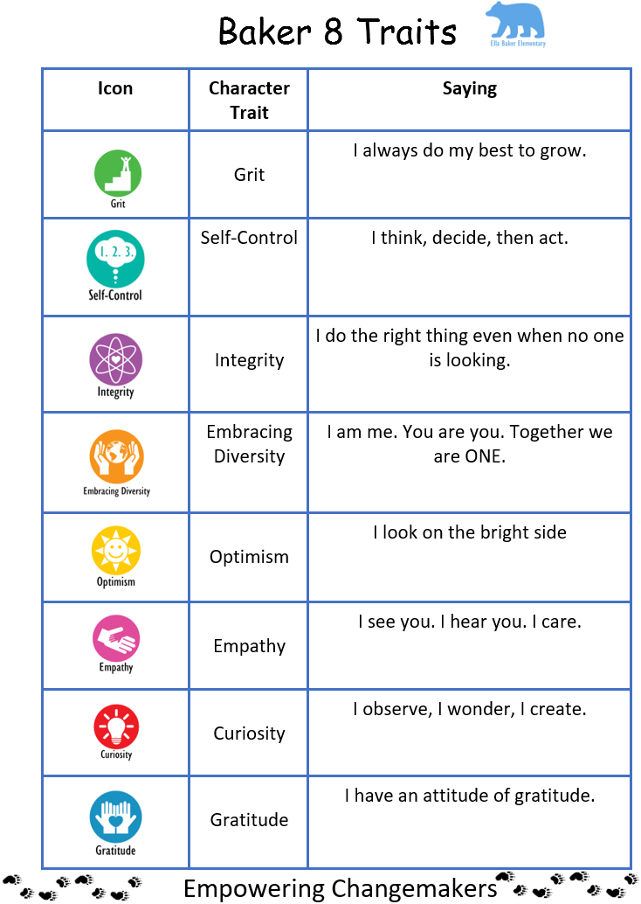
Our goal at Ella Baker is to develop global citizens who are empowered to make a difference in the world.

Ella Baker Service Learning
Ella Baker Elementary embraces a philosophy of service. To create more meaningful, engaging and empowering learning, students embark on large units of study with service learning at the foundation. So, what is service learning? We view service learning as a means to enable students to understand the world around them and the talents within them, so that they can become fulfilled individuals and active, compassionate citizens. Our goal is to tie classroom learning to real world problems and empower our students to make a meaningful impact in the world around them. We aim to go beyond the traditional community service model and strive for service that is the foundation of our learning instead of an add on. Truly integrated service learning seeks to boost civic engagement and encourage students to strengthen their communities through on-going relationships with people and places. We hope that you will join us on this journey towards supporting the next generation of changemakers.

Administrative Team
Kim Bilanko, Principal kbilanko@lwsd.org

I am thrilled to be the principal of Ella Baker Elementary School. We have an incredible team of educators who will be working with our amazing students and families to create a legacy. We are eager to grow our students academically and socially. At our school, students will learn important character traits, the Baker Eight Traits, which will help students be empowered to be themselves, get along with others and positively impact our world.
I am looking forward to getting to know each and every one of you! You can read more about me on our web site at: https://ellabaker.lwsd.org/about- us/meet-the-principal

Erica Gray, Associate Principal egray@lwsd.org

I am excited for the privilege to serve as Associate Principal at Ella Baker Elementary School. I feel honored and privileged to join a community of educators, of changemakers. The purpose and vision: to empower changemakers who know themselves, understand others, and are inspired to make an impact on our world resonates with one of my values and beliefs for the purpose of public education.

I am a proud University of Washington Husky! I received both my BA and MIT at UW. I have taught high school and middle school, as well as working with teachers as an instructional coach. Most recently, I was Blackwell Elementary’s Associate Principal for the past two years. It is important that all students have a sense of belonging when they step into the halls of our school and we, as educators, must meet our students with high expectations, knowing that all students can be successful. When teachers, staff, and family members work together, we can move mountains in a child’s life. A famous African proverb says, “It takes a village to raise a child.”

I believe in the power of education, and I am excited to work alongside each of you as we empower changemakers within our school.

Name | Position | Email Address
Kim Bilanko | Principal | kbilanko@lwsd.org
Erica Gray | Associate Principal | egray@lwsd.org
Renata King | Office Manager | reking@lwsd.org
Jill Brunke | Registrar | jbrunke@lwsd.org
Becky Dobbe | Health Room Secretary | rdobbe@lwsd.org
Shayla Dressler | Nurse | sdressler@lwsd.org
Melissa Foss | Counselor | mfoss@lwsd.org
Liz Czerwinski | CIS | c-lczerwinski@lwsd.org
Kaitlin Hudson-Mott | Psychologist | khudsonmott@lwsd.org
Kai Redman | Kindergarten | kredman@lwsd.org
Lindsey Thomas | Kindergarten | linthomas@lwsd.org
Angie Angel | 1st Grade | aangel@lwsd.org
Molly Conner | 1st Grade | mconner@lwsd.org
Barbara Hinton | 1st Grade | bhinton@lwsd.org
Gretchen Sattler | 1st Grade | gsattler@lwsd.org
Becky Mayer | 2nd Grade | remayer@lwsd.org
Ali George | 2nd Grade | ageorge@lwsd.org
Francesca Collier | 2nd Grade | fsmythies@lwsd.org
Joanna Hecker | 3rd Grade | jhecker@lwsd.org
Annie Park | 3rd Grade | annpark@lwsd.org
Robin Miller | 3rd Grade | romiller@lwsd.org
Natalie Stine | 2/3 Quest | nstine@lwsd.org
Jessi Kunkel | 4th Grade | jkunkel@lwsd.org
Chris Carter | 4th Grade | chcarter@lwsd.org
Keith Hutchinson | 4th Grade | khutchinson@lwsd.org
Aimee Ashley | 4/5 Quest | aiashley@lwsd.org
Casey Conroy | 4/5 Quest | cconroy@lwsd.org
Becca Gillman | 5th Grade | rbixby@lwsd.org
Tricia Neilson | 5th Grade | tneilson@lwsd.org
Kaley Rugh | 5th Grade | krugh@lwsd.org
Heather Murphy | Special Education | hmurphy@lwsd.org
Kit Craig | Special Education | kitcraig@lwsd.org
Erin Wing | Safety Net | ewing@lwsd.org
Lorelle Skellie | Safety Net | lskellie@lwsd.org
Kristin Sterrett | Safety Net | ksterrett@lwsd.org
Kym Gomez | ML | kgomez@lwsd.org
Reyhan Tatli | ML | rtatli@lwsd.org
Bailey Noble | Music | bnoble@lwsd.org
Cece Leavitt | Music Itinerant | celeavitt@lwsd.org
Caroline Towles | PE | ctowles@lwsd.org
Ashton Staudacher | PE Itinerant
Stephanie Johnson | Librarian | stjohnson@lwsd.org
Spring Cheng | SLP | sicheng@lwsd.org
Jennifer Santoyo | OT | jesantoyo@lwsd.org
Kristin Raffensperger | PT | kraffensperger@lwsd.org
Marianne Brewer | Instructional Assistant | mabrewer
Crystal Fewtrell | Instructional Assistant | cfewtrell@lwsd.org
Michi Guenther | Instructional Assistant | mguenther@lwsd.org
Sheetal Chinoy | Instructional Assistant | schinoy@lwsd.org
Mamta Dhingra | Instructional Assistant | mdhingra@lwsd.org
Shalini Tadakapalli | Instructional Assistant | stadakapalli@lwsd.org
Casey Griner | Para/IA | cgriner@lwsd.org
Daisy Villegas | Para/IA | dvillegas@lwsd.org
Roohi Mahboob | Para/IA | rmahboob@lwsd.org
Emily Landgren | Para | elandgren@lwsd.org
Becky Jung | Para | rejung@lwsd.org
Arsen Tugan | Head Custodian | artugan@lwsd.org
Hyan Kim | Evening Custodian | hykim@lwsd.org

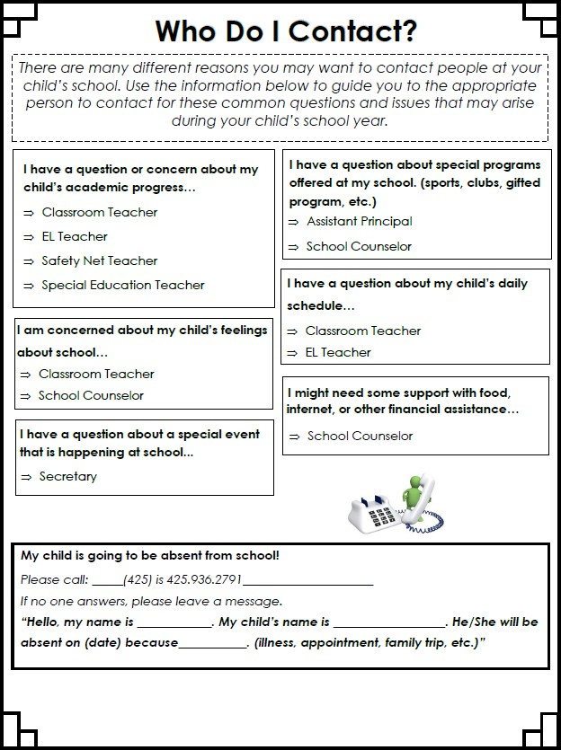

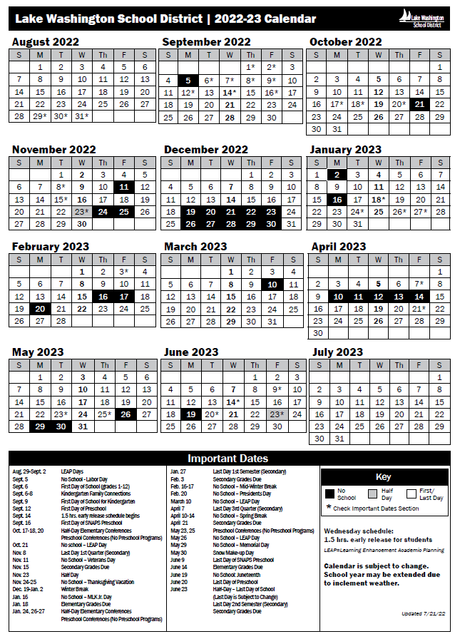

2022-2023 School Day Ella Baker Elementary

Monday, Tuesday, Thursday, Friday
9:00-9:15 Student Drop-off
9:15 First Bell:
All students in team lines
9:20 Second Bell:
Instruction Starts

Drop Off – Students are to wait for the first bell to ring near their teacher line on the blacktop. The playground is not open before school.
Pick Up – Students are to go directly to their afterschool pick up location when the bell rings.

10:26-10:41 | K-1 Recess
10:41-10:56 | 2-3 Recess | Wednesday
10:56-11:11 | 4-5 Recess |  | AM and Lunch stay same
11:45-12:05 | K-1 Lunch |  | No PM Recess
12:05-12:35 | K-1 Recess | 2:20 | Student Dismissal
12:15-12:35 | 2-3 Lunch | 2:30 | All students off campus
12:35-1:05 | 2-3 Recess
12:45-1:05 | 4-5 Lunch
1:05-1:35 | 4-5 Recess
2:15-2:30 | K-1 Recess
2:30-2:45 | 2-3 Recess
2:45-3:00 | 4-5 Recess
3:50 | Student Dismissal
4:00 | All students off campus

Ella Baker PTSA Contacts http://ellabakerptsa.org/Page/Ptsa/BoardMembers

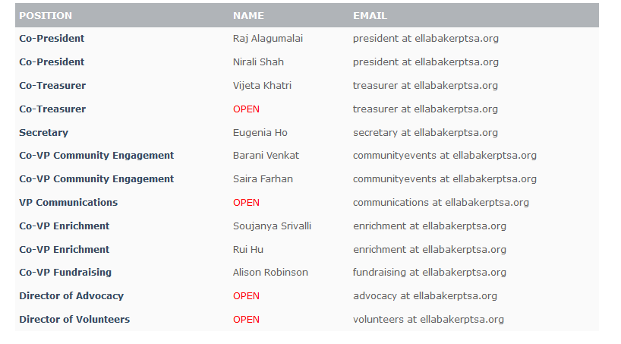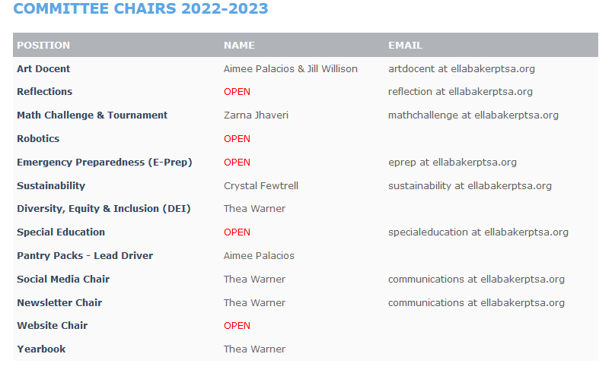
Ella Baker Procedures and Guidelines

Communication
The following methods give our parents updated information about classroom activities, curriculum and special events:
- Ella Baker Website https://ellabaker.lwsd.org/
- Ella Baker PTSA Website http://ellabakerptsa.org/Home
- Ella Baker E-Newsletter: Bear Tracks
- Ella Baker PTSA Newsletter: The Bear Den http://ellabakerptsa.org/Page/ptsa/BearDen
- Ella Baker Facebook Page https://www.facebook.com/groups/EllaBakerElementary/
- Teacher Newsletters

Contacting Staff
Email is the most efficient method for communicating with staff, especially during the school day. Emails are best for a quick question or to set up a request for phone dialogue. Please keep emails brief, as teachers have minimal time to check and respond during the day. You may request a conference with your child’s teacher or other staff member through email or a written note. The Admin Team and Office Staff may be reached through email or by telephone at 425-936- 2790. Teachers cannot usually be reached by phone during the school day except in an emergency. If you need to let us know of time sensitive information, such as a change in pick up plans, contact the office.

Conference Weeks
Parent/teacher conference provide time for parents to meet with teachers and discuss their child’s progress in school. These are student-led conferences so please plan to have your child present. Parents are welcome to request additional conferences at any time.
Fall Conferences October 17, 18, 20
Winter Conferences January 24, 26, 27

Ella Baker Library
Students can check out or renew books as long as their records are free of fines and overdue books.
- KDG – 1 book for 1 week (starting in Oct.)
- 1st – 1 book for 1 week
- 2nd – 2 books for 1 week
- 2/3Q & 3rd – 3 books for 2 weeks
- 4th – 4 books for 2 weeks
- 4/5Q & 5th – 4 books for 2 weeks

Overdue Policy
Renew: Students may renew a book by bringing it to the library during their weekly library time. Students may renew a book one time.
Overdue: Notices are printed weekly and given to students. This is the student’s reminder that their book is overdue and needs to be returned asap. Fines are not issued for overdue materials. However, students may not check out a book until overdue materials are returned. Consistently having overdue materials may affect a student’s library grade.

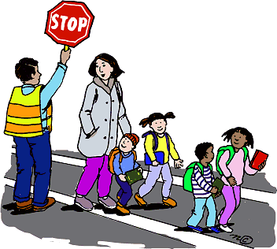
Lost or damaged: Materials will be assessed and a fine will be issued to replace the book in the library collection. Students are responsible for their library books.

Safe Arrival, Dismissal, and Attendance Procedures
If your child will be absent from school, please have a parent/guardian call the school attendance line before 9:20 am. The line is open 24 hours a day.

Arrival
- Students can arrive at school at 9:00.
- Students arriving by car should be dropped off in front of the school.
- All students will enter through one gate (next to the fire gate entrance to the playground).
- Students will be able to stand in their class lines on the playground starting at 9:05 and will then start entering the building at 9:15.
- We will allow adults to bring students to line-up the first two weeks of school. We ask adults to promptly get students to their line and say goodbye.
- After two weeks, we will be asking adults to say goodbye at our gate.

Late Arrival
It is important that students be on time. It can be disruptive to the educational process to have students arrive late. There are, however, instances when students will be excused upon arriving late to school (i.e. a doctors or dentist appointment). If your child is going to be late to school, please have a parent or guardian call the attendance line before 9:20 am.

Dismissal
School ends at 3:50 (and 2:20 on Wednesday early release days). There are 2 car pick-up loops: Blue Loop and Green Loop.
•Blue Loop: Families with the last name starting with A-M (student’s last name).
  - Green Loop: Families with the last name starting with N-Z (student’s last name).
    - If you have a carpool, the loop is determined by the driver’s student’s last name. For Instance, if Malia Beck’s mom is picking up the carpool, students will meet in the Blue Loop (A-M).
  - Pick-up loops do not open until the bell rings at 3:50 (Mon, Tues, Thurs, Fri) and 2:20 (Wed).
  - Families who arrive prior to the bell will need to park in the visitor parking.
  - If visitor parking is full, families will exit the parking lot. Additional parking is available in the Redmond Ridge East Recreation Parking Lot.
  - To keep traffic flowing, there will be no waiting or parking on Eastridge Drive. In addition, there will be no left turns from Eastridge Drive into our pick-up loops.
  - Vans: Van pick-up will be in the visitor parking lot.
  - Bikers: Walk bicycles on campus at all times; use 1st rack until full and then overflow.
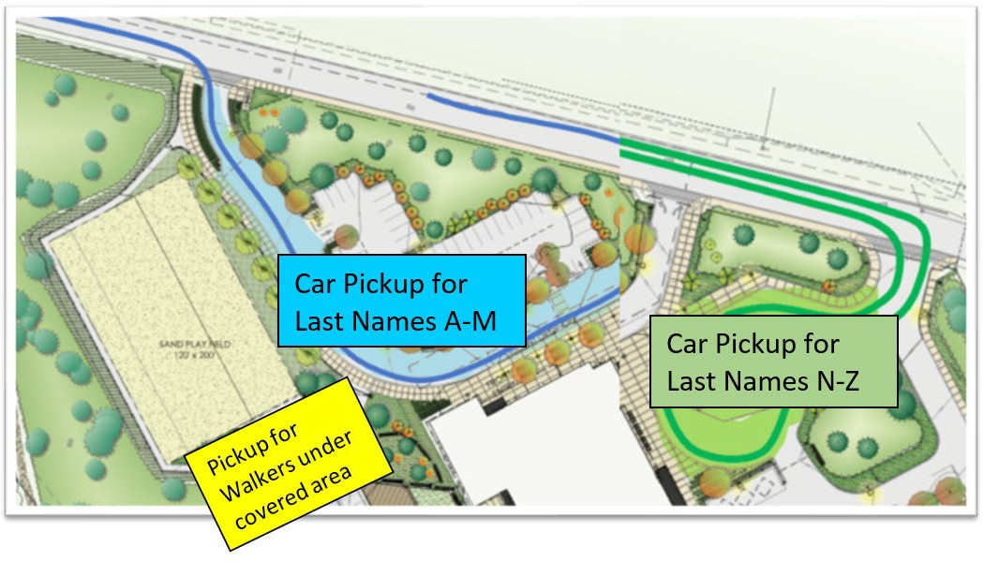
  - Walkers: Meet family at covered play area.
- Students not picked up by 4:00 pm will be brought to the office to wait to be picked up as there is no outside supervision at this time. PLEASE NOTE: The office closes at 4:15 pm. Wednesdays dismissal is 2:20 and students must be picked up by 2:30 as there is no supervision after school on Wednesdays.

Parking Lot Safety Safety Patrol
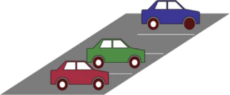
We have student leaders serving as our safety patrol. They go on duty at 9:00 a.m. and leave duty at 9:15 a.m. They are also on duty from 3:50 -4:00
p.m. They help students safely cross the streets and enter and exit cars.

Drop Off
At the Drop off in front of school, please stay in the right lane. Left lane is used for exiting the parking lot. Students must let out on the right side of the cars when unloading and loading to avoid on-coming traffic.
- The driver must stay in the car at all times.
- Students must be able to enter and exit a car independently to use the car drop off. If your child needs assistance loading/unloading or buckling their seat belt please park your car so you can meet your child and help them load.
- Please make sure your child is ready to exit when you pull forward (i.e. shoes on and tied, backpack and belongings easy to grab).

Bus Zone
Please do not park in the bus zone between the hours of 8 AM and 4 PM to allow buses to be able to enter and exit as needed.

Pets
For the health and safety of staff and students, please leave your animals at home when you are on campus. Per District Policy, “No dogs are allowed on district property between 7 a.m. and 4 p.m. on any school day, except for bona fide service dogs. No dogs are permitted in district athletic stadiums at any time, except for bona fide service dogs. At all other times dogs must be leashed and controlled by owners. Owner must clean up after their dogs and remove waste from district premises.

LWSD Elementary Attendance and Tardy Policy 2022-2023
Regular school attendance is important for all students. Chronic or excessive absenteeism, whether excused or unexcused, has been correlated with lower assessment scores and lower graduation rates.

Students may be excused from school, with the consent of their parents/guardians, for medical and dental appointments and to accompany their parents/guardians on out-of-town trips.
Additional absences consistent with WAC 392-400-325 will also be considered excused.

Parents or guardians should notify the school in person, by phone, or in writing/email within 48 hours of an absence if they wish to have the principal consider it as an excused absence.

Students who demonstrate chronic absenteeism or tardiness may be required to meet with school staff or the building principal to develop a plan to support the student's educational progress.

All students are expected to remain on campus for the entire school day. There are exceptions for high school students whose parents request that they be excused during lunch and students whose parents request attendance at another school or school-related activity during the school day.

Student Attendance Accounting
Regular daily attendance is required. Illness and unique circumstances may constitute legitimate excuses for absence. In such circumstances, the school must be appropriately informed by the parent or guardian or the student if he/she is of age and living apart from parent or guardian. Such communication should be in person, by telephone or in writing and within forty-eight hours following the absence.

In consultation with parent or guardian or the student who is of age and living apart from parent or guardian, the principal shall determine whether or not excessive absence is justified. If a student is judged to be truant, the principal shall take the necessary action to comply with state laws.

Truancy
Under Washington state’s truancy law RCW 28A.225.030, the school/district are required to take specific actions when students are truant.
- Parents will be notified in writing or by phone after one unexcused absence in a month.
- A parent conference will be initiated after two unexcused absences in a month in order to improve the student’s attendance.
- The parent and school must enter into a contract to improve the student’s attendance after five unexcused absences in a month, or the case may be referred to a Community Truancy Board,
- The school district may file truancy petitions with the juvenile court after seven unexcused absences in a month, or ten unexcused absences in an academic year.

Vacations
We recognize there are many reasons why a family may choose to take their student out of school; however, students cannot maximize their educational experience when they are absent. A significant amount of teaching and learning takes place during class time and cannot be duplicated at home. Family vacations must be pre-arranged in order to be considered excused. The pre-arranged absence form (see next page) must be completed at least one week prior to the absence. Failure to follow the procedures will result in the absence being reported as unexcused. Family vacations are special, but we ask that you consult the school calendar when making your vacation plans. Student achievement and classroom attendance are positively related. We urge you to plan your family vacation during the school breaks. Although every effort will be made to see that your child gains the needed learning, teachers are not required to assemble packets for such absences. Teachers are not expected to create additional assignments or remedial instruction for students who miss school as a result of vacation scheduled during school time.

Released Time for Medical and Dental Appointments
Pupils may be excused from school for medical and dental appointments upon request from parents. The pupil shall be counted absent if he/she is not in attendance at least 60 minutes of each morning or afternoon session of the school day. This practice should be discouraged, and appointments should be made outside school time whenever possible.

Released Time for Other Occasions
While it is deemed desirable that pupils be in attendance regularly, it is recognized that there are times when parents shall be out of town for short or extended periods of time. It also is recognized by the school that the best kind of supervision for the child is parental supervision. In cases where parents find it necessary to be out of town overnight or longer and feel that it is in the best interest of the child, the child shall be excused from school. It shall be the responsibility of the parent to make arrangements with the school for such absence. Provisions should be made by the parent for some program of study by the pupil in order that the pupil shall not be too far behind the instructional program in the classroom on his/her return to school. No child shall be excused from school for any reason without clearing through the principal's office.

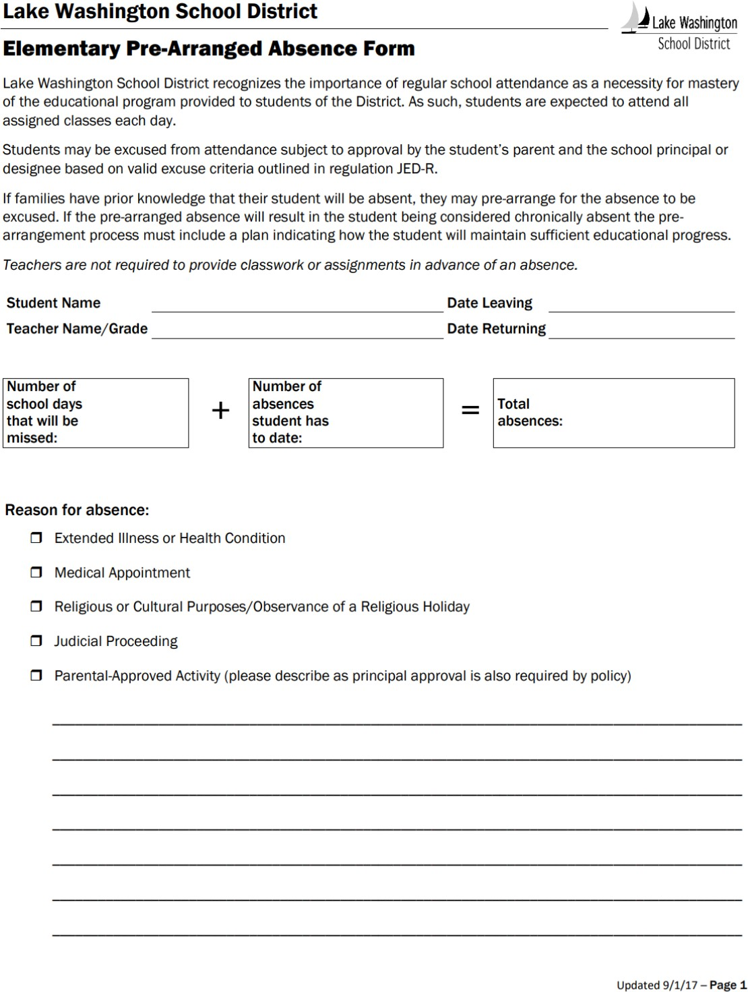

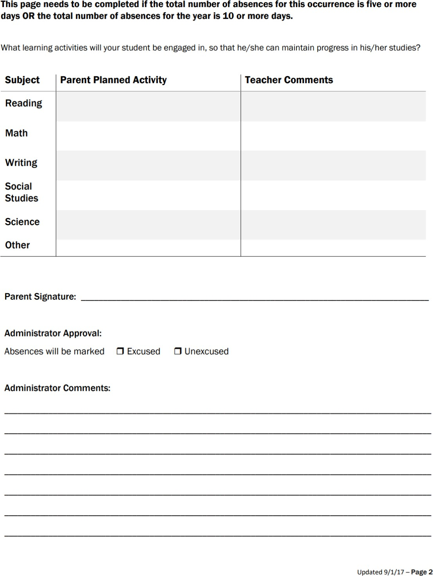

Health Room/Medication

Health Room
District nurses are assigned to multiple schools and are not assigned to a specific campus. Parents should inform the school on the student emergency contact card or in writing if a student has a life-threatening illness, infectious disease, or serious allergy.

Medications at School
The Lake Washington School district’s medication policy states that the only medication to be given at school must be doctor prescribed and needed in the event of a life-threatening situation. Students may not medicate themselves. If your child is currently taking daily medication, please arrange to have your child take it before school begins. Should medication need to be administered at school, parents must have their child’s physician sign the LWSD medication form (#4023); provide a separate prescription pharmacy bottle labeled by the pharmacist (handwritten labels will not be accepted); bring the pharmacy bottle with the exact amount of medication needed for the designated time period (no more than one month at a time) to school at least two days prior to administration; and must pick up any unused medication (i.e. Epi-Pens, inhalers, etc.) by the last day of school.

ALL MEDICATIONS (INCLUDING OVER-THE-COUNTER ITEMS LIKE TUMS, THROAT
LOZENGES, COUGH SYRUP, TYLENOL, ASPIRIN, ETC.) to be administered to a student by a school employee, must be requested and authorized in writing by a parent/legal guardian AND a physician/dentist. You may obtain a form in the office for this purpose. For student's safety, it is important that all medication be kept in the school office and administered by an employee.
Please do not put pills or over the counter medication into your child’s lunch!

Illness and Injury
Students who show symptoms of COVID-19 are required to stay home. They should get tested for COVID-19.

- When students have any of the COVID symptoms at school, they will wait in a “Q- Room” and then need to be picked up from school. They should get tested for COVID-19.
- Students who test positive for COVID-19 are required to isolate at home for 5 days. If symptoms improve and they have no fever for the past 24 hours without the use of fever-reducing medication, students can come back to school.
- Students returning from 5 days of isolation should wear a well-fitted mask from days 6-10. Students are also encouraged to test before returning to school.
- Students who test positive after 5 days of isolation must isolate for the full 10 days.
- Close contact status
Determination is based on the Too Sick for School - Lake Washington School District (lwsd.org)
When a child is sick or injured, it is important that they be picked up AS SOON AS POSSIBLE. Please be sure that the school has a telephone number of a nearby friend or relative that could come for your child quickly if you cannot be reached. Please update your work, home and emergency number with the school office when these numbers change.

Child Find
Child Find is a district program to help determine if your child has a disability and to help provide appropriate services. If you are concerned or have questions about whether or not your child has a disability, may have a developmental delay, know your child has a disability and are looking for appropriate education services or would like to know how to help their school age child succeed in school, then contact Child Find. For more information visit the district Child Find website.

Celebrations, Holidays, and Parties
Birthdays are special days for students, and we love celebrating each of our students. Please check with your classroom teacher to find out how their class celebrates. As a school, we will not be celebrating using treats or goodies in the classroom.
We will have three school parties. We will celebrate a costume parade on October 31st and Friendship Day on February 14th, as well as an end-of-year, kick off to summer party. Each classroom will have their way of celebrating these events. Foods provided for school-sponsored parties, events, rewards, and/or incentives shall comply with the restrictions for food sales. Occasional school-sponsored class parties and celebrations or school-wide events shall be exempt from LWSD guidelines, however providing healthful options is strongly encouraged. No more than three such exceptions shall take place in a given school year.

Parent and Visitor Procedures

We welcome families to visit Ella Baker, and to volunteer in the school or for a PTSA activity. Please note that at this time, due to COVID-19 health and safety protocols, our state requires volunteers to be fully vaccinated to protect against COVID-19 or to have obtained a medical or religious exemption. When visiting or volunteering at the school, please check in at the office first and wear an identification badge. This helps keep our children safe!

Entry Control System
LWSD has entry access control systems in all schools to help ensure we know who is in the building. This system allows us to keep all doors locked and use a camera and doorbell system for visitors to gain access to the building.

What to Expect for Parents: When you arrive at school during business hours, enter through the main door. Please give your name and purpose of your visit after ringing the doorbell (e.g. I am here to pick up my student, I am Vo, I am dropping off something for my student). Upon entering, proceed to the office, present ID, and check in. Please wear your Volunteer ID badge at all times when in the building.

What to Expect from Staff: Staff will review safety expectations periodically throughout the year and will wear identification badges at all times. Staff will escort any adult in the building without an ID badge to the office for check-in. Staff will keep all interior and exterior doors in a locked position at all times and direct traffic to the front door. To accommodate large groups of students and parents, we will create small windows of time with a staff 'greeter' in lieu of the Entry Control System.

If you wish to volunteer, or chaperone a field trip, you must complete a Lake Washington School District Volunteer Application form. All Lake Washington School District volunteers must go through a screening process, for the safety of students and volunteers alike. Please visit the website at: http://www.lwsd.org/Parents/Parent-Access/Pages/Online-Volunteer- Application.aspx. Or, see the office staff for more information.

Volunteer opportunities for PTSA activities are available online at: https://rosaElla Bakerptsa.ourschoolpages.com/Packet/VolunteerAll/SignInPacketPage/0.

Volunteer Guidelines
Please note that at this time, due to COVID-19 health and safety protocols, volunteers are not allowed in classrooms or student learning spaces when students are present.
Website: https://www.lwsd.org/get-involved/volunteer-programs/volunteering-in-lwsd/volunteer- application-process

Parents/guardians of Ella Baker students are welcome and encouraged to volunteer at our school. To become a volunteer, it is a district requirement so complete a Volunteer Application form, which can be obtained from the Office Manager or online. This application is good for two years. For security reasons, we do require that all volunteers and visitors sign in on the

appropriate sheet in the office when they arrive and wear a name badge for identification. Please sign out when you leave the school.

When you are working in the school, you have the authority and responsibility for helping students learn and work together cooperatively. No alcohol, controlled substances or tobacco will be consumed or used on school grounds or when attending school outing with students.
- Volunteers may act immediately on judgments of student safety. Volunteers should not put their hands on students.
- Volunteers are encouraged to ask for direction, clarification or assistance from staff.
- Volunteers should arrange a meeting with teacher to discuss concerns about their child/program outside of volunteer time.
- Volunteers in the building during school time should refrain from conversing with each other in a way that might disrupt classroom activity.
- When visiting classrooms, volunteers are urged to actively assist students or to participate in activities as a learner.
- Volunteers should not discuss other student issues regarding behavior or academics in or outside of school.

Tips for Volunteers:
- Respect the child’s right to privacy. As a guest in the lives of children and their families, confidentiality is expected at all times.
- Refrain from taking and posting pictures of our students. Staff members are happy to capture special moments for you if you ask them for assistance.
- Let the child know that you care. All children like to feel there is some special adult who really likes them.
- Be a good role model. Children will be looking up to you and learning from you. When you demonstrate positive behaviors, they will follow your lead! If you need to check in on your phone, please excuse yourself from your volunteer duties until you are finished.

Lake Washington School District
Raptor Volunteer Application Helpful Information

We would like to thank you for your interest in volunteering in the Lake Washington School District. We recently launched a new volunteer management system with Raptor Technologies. Any new program creates many questions. Here is some information that may help you understand how this system works.

- If your application was still valid in the previous volunteer system, it is still valid in the Raptor system.
- Applications are still valid for two years.
- We are still running background checks through the Washington State Patrol Washington Access to Criminal History (WATCH) system.
- You will receive a reminder email from Raptor 30 days prior to the expiration date of your application.
- The Raptor system will only allow you to renew your application if you are within 30 days of the expiration date of your previous application.
- Raptor creates user accounts based on email addresses. If the same email address was used for more than one application, Raptor will only be able to create one user account. If you need help updating an email address, please contact Chris Robison at crobison@lwsd.org.
- You can apply or renew your application through the LWSD website. Go to lwsd.org, hover over the Get Involved subject heading. Select Volunteer Programs. On the right- hand side, you will see a quick link to the Raptor Online Volunteer Application.
- Once you submit an application, you will receive an email confirming receipt of your application.
- When your application is processed you will receive an email alerting you to your status.
- After approval, Raptor will send you an invitation to activate your Raptor Volunteer Portal.
- If you activate your Raptor Volunteer Portal, you will see your profile. The only changes you can make to your profile are your address and phone number. To make any other changes while your application is approved, you will have to contact Chris Robison at crobison@lwsd.org.
- At this time, you cannot renew your application from your Volunteer Portal. You will have to log out of the Raptor Volunteer Portal and follow the steps outlined in number 7.
- In the Volunteer Portal there is a “Community” tab. This is a list of volunteers who have opted to have their emails added to this list (on the Preferences tab). At this time the list is not filtered by school. Raptor will be improving this functionality shortly, so you would only be able to see volunteers at your school.

Your volunteer work is an essential element to the success of our students. On behalf of all students and staff, thank you!

Lunch Program Procedures

Free and Reduced Lunch Program
For the 2022-2023 school year, breakfast and lunch will be offered to all students who qualify based on family income level.

Lunchroom
Lunch is served and eaten in the cafeteria each day. Lunch is eaten in the cafeteria and is not allowed on the playground.

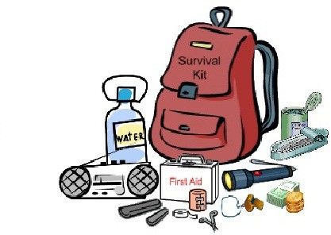
School Emergency Information and Procedures

WAC 392-145-045 Emergency Drills
Emergency drills conducted pursuant to WAC 392-145-040 shall make allowance for individual differences in exiting the emergency door and should provide instruction to helpers that they should offer a helping hand palm up and grasping a student’s hand or arm. Students should also be taught to remember that most accidents are preventable, regardless of who may be at fault, and that proper behavior and good conduct on the bus is the best way to assist the driver in the safe performances of his/her duties.

Parent/Guardian Information for a School Emergency
The staff at Ella Baker Elementary takes our responsibilities to keep your children safe and secure very seriously. If an emergency occurs that requires the school to close early, such as a snowstorm or a windstorm, or requires us to evacuate the school building, such as a fire or earthquake, we have detailed plans in place to care for our students and reunite them with their parents as quickly as possible.

As a parent, there are things you can do to help us in this effort in the event of an emergency. The most important thing you can do for your children is to stay calm. Please review this information and share it with any person that you have authorized to pick up your child in the event of an emergency.

After an Emergency:
- Do not call the school; there are district procedures for informing the public via radio, school messenger and television.
- The parking lot may be closed off to allow access only for emergency vehicles. Do not block the entrance to the parking lot.
- If you live nearby, please walk to reduce traffic congestion.
- If you drive, please be courteous, and park where there is space.
- Be sure to bring your picture I.D. with you to the school. We are required to identify each individual picking up a child.
- Ensure that your emergency card is up to date. We will only release students to someone on the emergency contact card.

Pick-Up Procedures
If the emergency is one in which we have not had to evacuate the school building, enter the school through the main entrance by the office and follow the instructions you will receive there. Please do not enter the school building by any other doors.

If the emergency is one in which we have evacuated the school building, please follow the procedure outlined below.
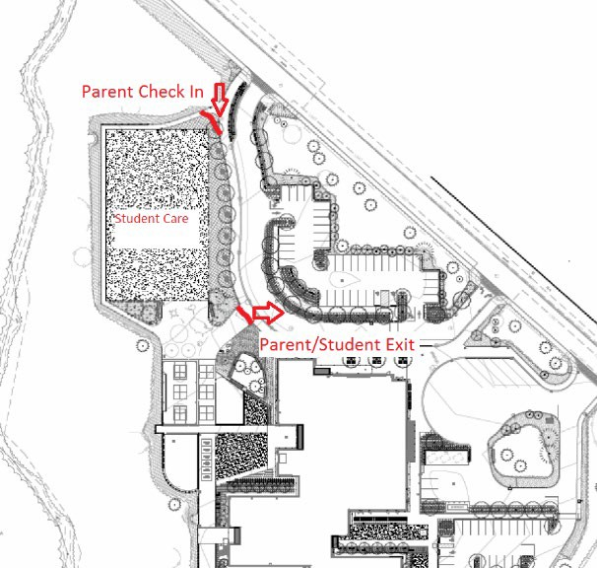
- If you are already at the school or arrive before things are set up, it is VERY important that you do not leave without signing out your children.
- All students will be in a safe and secure location, most likely the sports field. Designated staff will account for each student.
- There will be Parent Check-in area at the gate located on the path as you enter campus. Parent/Guardian or emergency contact will show picture ID and sign a Student Release Form for each child you are authorized to pick up. Please make sure your emergency contacts are up to date.
- After you have signed a Student Release Form for each child, the staff will reunite you with your child(ren) at the Park and Ride gate.
- It is very important that you do not go directly to your student without following proper procedures.

Volunteering during an emergency
If there is a need for additional volunteers to assist our staff in an emergency situation, we will activate a volunteer area where parents can go to sign up for volunteer tasks. Your children will remain with the other students and be notified that you are volunteering; you will also get confirmation that they are OK before you begin your volunteer tasks. When you are finished volunteering, please sign out and fill out a Student Release form for each child.

Homework
We believe homework can:
- give students the opportunity to practice and reinforce skills (academic, social-emotional, and service-learning).
- extend and enrich daily learning.
- engage families in the learning that is happening at school.
- give students the opportunity to practice responsibility, organization, time-management and character traits.
We believe in a balanced approach: academic learning with social- emotional and service learning. We believe students and families
should regularly engage in reading. We believe in a variety of homework to help meet our students’ different learning needs.
Time Guidelines
We believe all students are different and that we should offer flexibility for students. We believe family time, play and relaxation should be balanced with learning and responsibilities. On average, students may spend approximately:
Grades K-1: 15 minutes of homework/night Grades 2-3: 20 minutes of homework/night
Grades 4-5: 30 minutes of homework/night

Ideas for Helping Students at Home
- Ask student about what they are learning at school.
- Help student develop a regular habit of checking for homework and due dates.
- Help student find a work time and space that matches their learning styles.
- Help teach student time management and organization.
- Communicate questions, concerns, or positive feedback with teacher.
- Find service opportunities within communities (e.g. home, service organizations, clubs, teams).
- Practice life skills and character traits outside of school.

Ella Baker Student Expectations

Here at Ella Baker we believe in growing our students. We practice in a school-wide system approach to create a positive learning environment designed to increase academic performance, improve safety, decrease problem behaviors, and establish positive school culture. Please visit PBIS.org or PBISworld.com for more information.

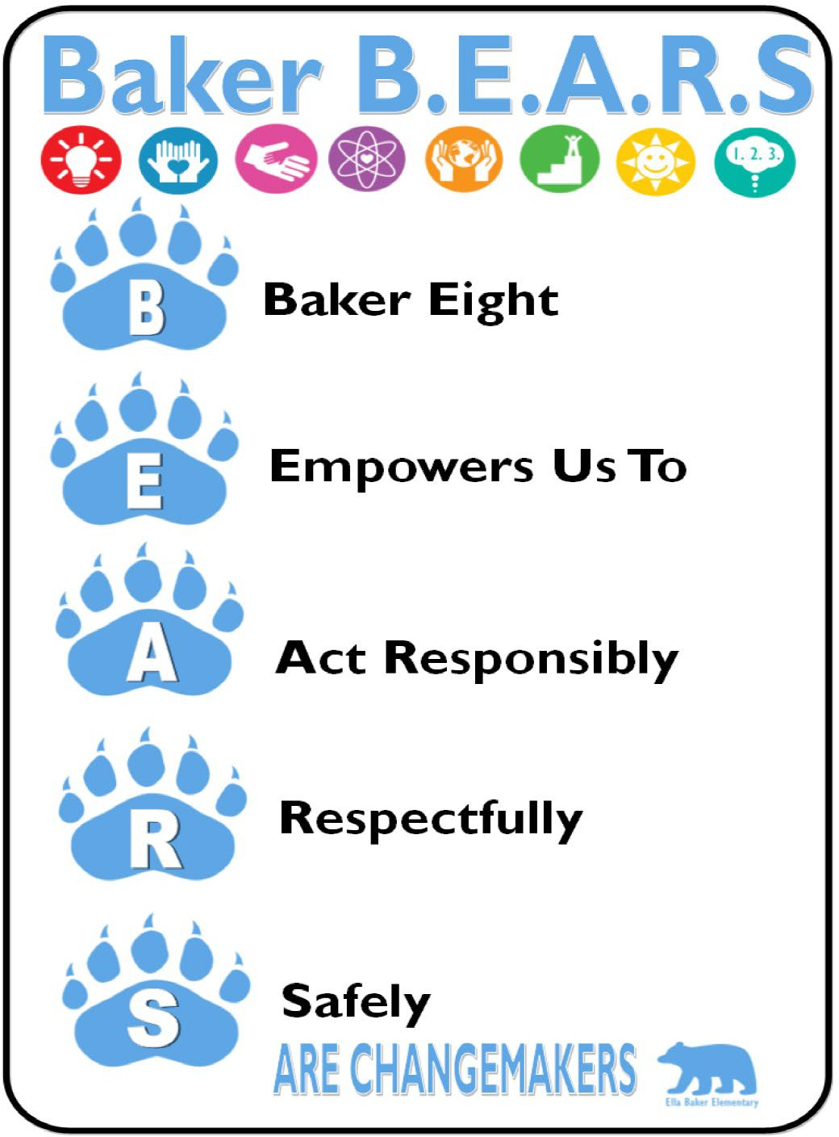
Students will be acknowledged by receiving a BEAR BADGE ticket by demonstrating Baker Eight Traits that enable responsible, respectful, safe behaviors.

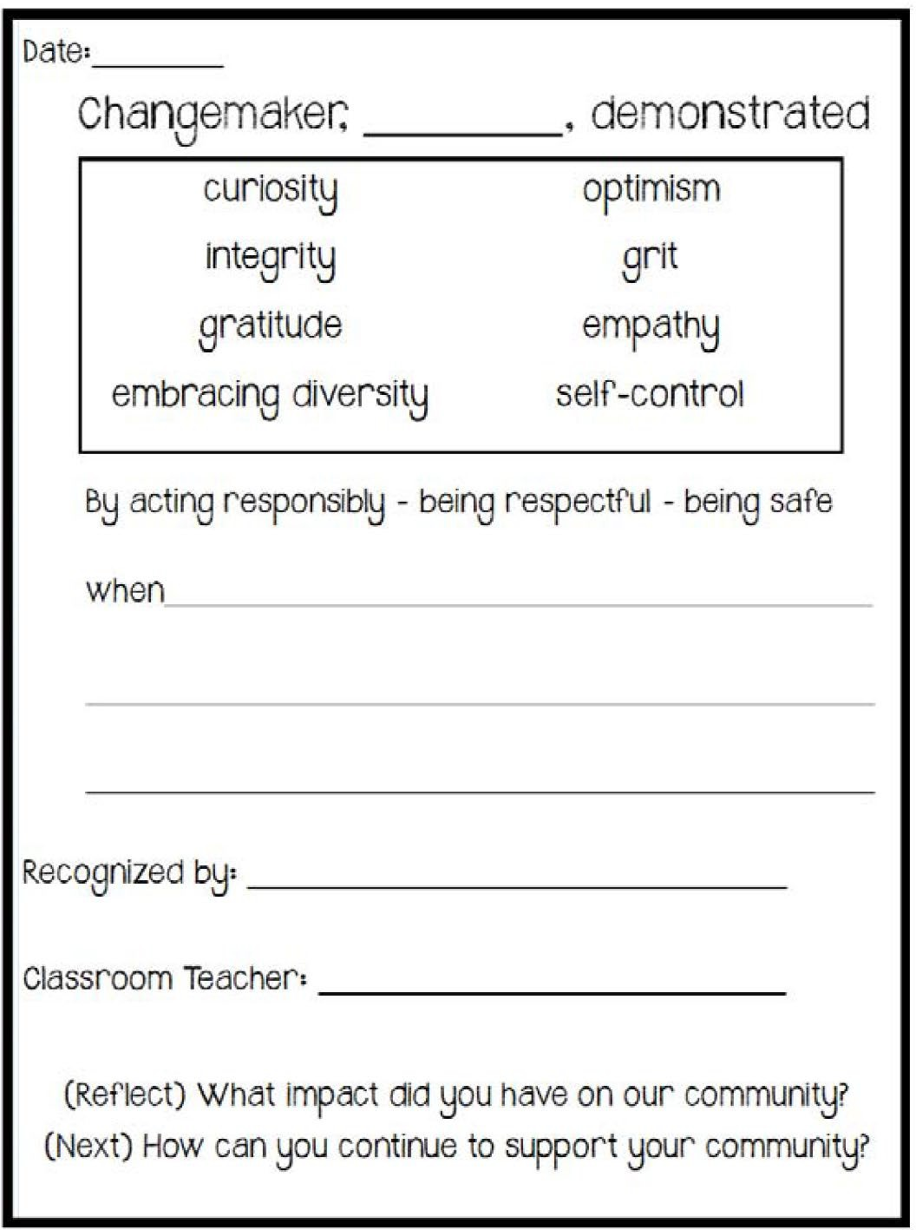

Consequences for Inappropriate Behavior
To help students grow, the staff will work directly with students and families to support students in making responsible, respectful, and safe choices. When a choice is made that isn’t respectful, responsible, or safe, students will learn how to reflect on their behavior and make things right. Consequences for inappropriate behavior may occur and may include one or more of the following:
- Ella Baker Reflect and Restore Plan. (see below)
- Teacher developed consequences (e.g., phone call home, written work, etc.).
- Loss of recess, time-out in the classroom, in another classroom or in the office.
- Student/parent/teacher and/or principal conferences.
- Restitution or school community service.
- In-school suspension.
- Out-of-school suspension.

Our goal is to provide students the opportunity to correct their own behavior.
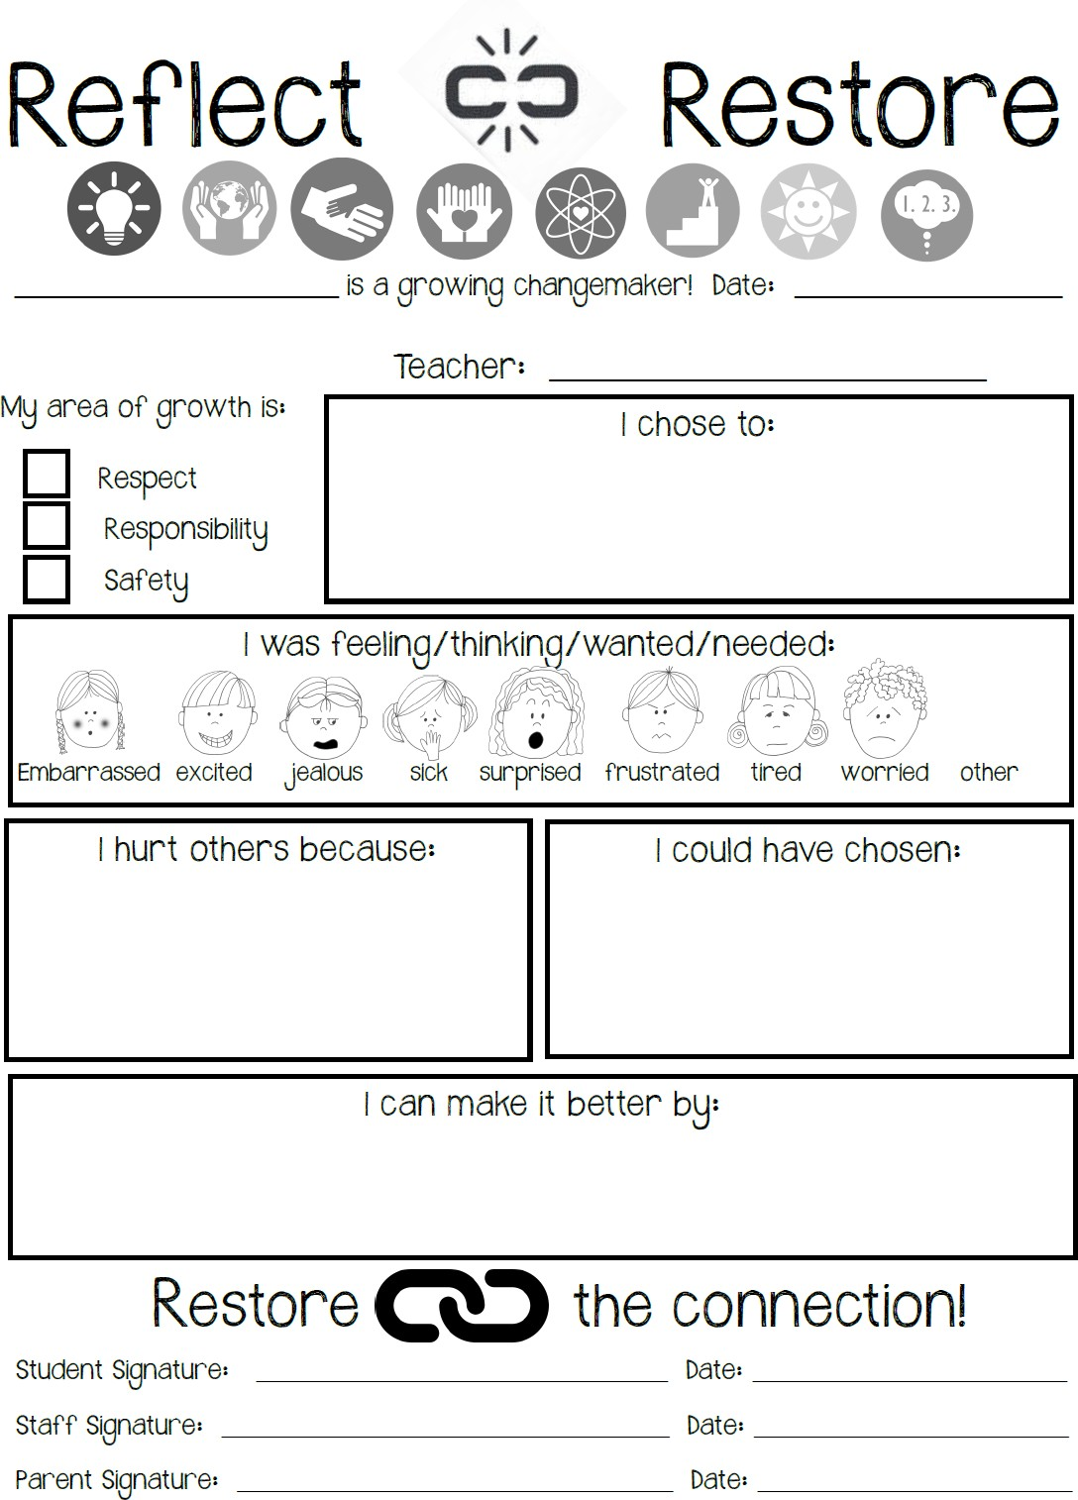
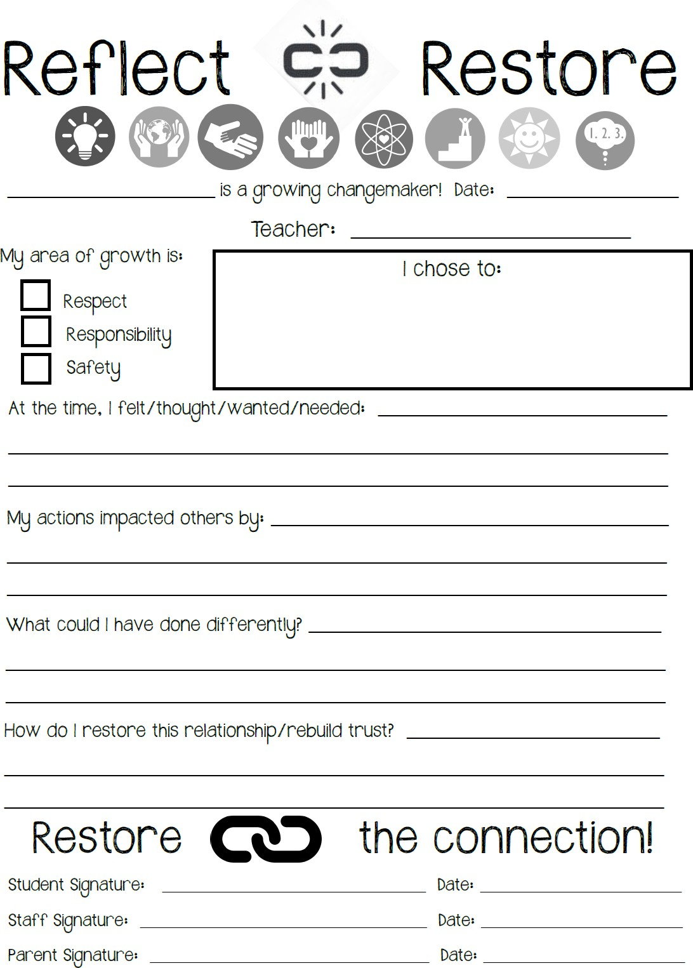

Primary Reflection Sheet Intermediate Reflection Sheet

At the end of the document you will find the Lake Washington School District 2021-22 Student Rights and Responsibilities. This document outlines the LWSD policies surround specific violations such as fighting, harassment, vandalism, etc. and outlines progressive disciplinary action that may be taken.

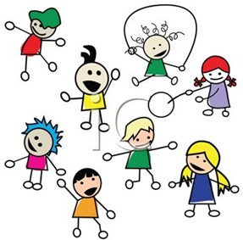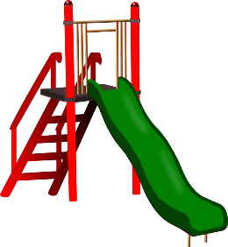Playground Policies
General Expectations BEARS on the playground Respectful
  - Use positive and appropriate language.
  - Play with everyone who wants to play.
  - Listen and follow directions of adults on the playground.

Responsible
  - Be a problem solver. Use your Baker Eight Traits.
  - Line up at first signal.
  - Report problems and injuries to the nearest adult.
  - Agree on rules before a game and follow them.

Safe
  - Keep hands and feet to yourself.
  - Use equipment appropriately.
  - Stay in approved areas.
  - Keep play chips, sand, rocks, and sticks on the ground.

Be a FRIEND. Be FAIR. Be SAFE.

Items not allowed on the playground:
  - Electronic equipment (cell phones, iPods, etc.)
  - Personal toys (stuffed animals, Pokémon cards, transformers, etc.)
  - Chewing gym, food, beverages
  - Hard balls such as baseballs/softballs

Rainy Day Recess
All students will go out for recess daily except in the case of severe weather (lightning & unsafe wind). Students are to use “common sense” during periods of inclement weather. They should stay under cover, stay out of puddles and away from downspouts and be prepared with proper attire, raincoats, boots that are water resistant. Umbrellas are not allowed on the playground. A doctor’s note is needed in the case your child needs an alternative plan for outdoor recess due to illness or injury.

Personal Items and Electronics
Cell Phones: Cell Phones are allowed at school but must remain OFF and in student backpacks during the school day (9:20am to 3:50pm).

Smart Watches may be worn by students if they do not become a distraction in the classroom (teacher discretion). If student needs to use the watch to communicate with a parent/guardian (text or call), this must be done with permission in the office, just as they would when using the

school phone. Cameras (on phones or watches) may not be used under any circumstance on school property or vehicles.

eReader: Authorized use of eReaders (such as Kindles or Nooks) is allowed in the classroom upon teacher approval. A Release of Liability Form must be signed prior to eReader usage at school.

All other personal electronic devices are not allowed on campus or on school buses unless authorized by a staff member. We believe in preparing students for the technological world, therefore all students will have access to Netbook computers during the school day.

Items to Leave at Home:

  - All electronic equipment
  - Games
  - Toys
  - Trading cards
  - Expensive items (cameras, binoculars, etc)

Bicycles, Skateboards, and Scooters

Bike/scooter riders are responsible for following these rules. Students who violate these rules risk the suspension or loss of their bike/scooter riding privileges.
The district encourages the use of bicycles as a mode of transportation to school when safe. Bicycle routes designated by the local cities and county are included in the Suggested Walk Route maps. All elementary students above the age of 10 may ride a bicycle to school with a completed permission form signed by the parent/guardian. For students under the age of 10, an adult need to accompany the student both to school and on the return home. https://www.lwsd.org/about-us/policy-and-regulations/suggested-walk-routes-and-bicycle-policy- eeab
- All bike/scooter riders must have an approved “Safe Bike/Scooter Club Membership Registration” form on file in the office.
- All bikes/scooters must be parked in the bike rack with approved bicycle/scooter registration number visible.
- All bikes/scooters must be walked on and off the school grounds. Bike/scooter riding is not permitted on the school grounds during school hours.
- Every bike/scooter must have a lock. This is the best means of preventing someone from riding your bike/scooter. You must have your own lock, and not share with a friend.
- Every rider must wear an approved safety helmet when riding to and from Ella Baker Elementary.
- Bike/scooter riders shall use all hand signals employed by the driver of a car. (Applicant should learn these if he/she does not know them before riding their bike.)
- Keep to the right and ride in a single file. Keep a safe distance behind all vehicles.
- Look out for cars pulling out into traffic. Keep sharp lookout for sudden opening of car doors.
- Only one person per bike/scooter.
- Ride in a straight line. Do not weave in or out of traffic or swerve from side to side.
- Slow down at all street intersections and look to the right and to the left before crossing. Stop at stop signs! At all intersections, where school patrol is present, riders must dismount and cross in the crosswalk, pushing their bike/scooter as a pedestrian.
- Both hands should be used in steering the bike/scooter, except when using one hand for signaling.
- Be sure brakes are operating efficiently and keep the bike/scooter in perfect running condition.
- Give pedestrians the right of way. Since pedestrians and bikes/scooters share sidewalks and other paths. Special care must be taken, as walkers have the right of way.
- Private property must always be respected.

Dress Guidelines

Clothing for Students: Students may express individuality in their dress or appearance as long as their appearance does not cause or have the potential to cause a disruption to the educational process for themselves, other students, or staff.

The following guidelines are designed to promote a positive, safe, healthy learning environment:
- Shoes should be appropriate for running, climbing, and playing on recess equipment, stairs, outdoor terrain, and participating in P.E.
- Clothing covers underwear and torso (stomach and back). Layered tank undergarments are allowed.
- Clothing does not promote alcohol, tobacco, drugs, sexist/racist themes, profanity, violence, illegal/dangerous weapons, sexual connotations or gangs.
- Headwear must be worn in a respectful and responsible manner.

If a student is dressed inappropriately, staff will follow the outlined referral process in a discrete and respectful manner that limits impact on student learning time. For isolated incidents, referral process includes a verbal reminder of dress guidelines and appropriate clothing given to student if necessary. For repeated or severe incidents, administration/counseling staff will offer support by problem solving dress guideline obstacles with student, as well as giving or contacting parents to provide other appropriate clothing.

Lost and Found
“Lost and Found” items are collected and placed in the alcove next to the main office. Please remind your child to check in the “Lost and Found” regularly when they misplace items. PLEASE MARK ALL ARTICLES OF CLOTHING AND OTHER PERSONAL ITEMS
WITH YOUR CHILD’S NAME. The school district, by law, cannot pay for lost, stolen or broken personal possessions of students, such at watches, coats, musical instruments, cell phones etc. All unclaimed clothing will be donated to a charity at various times throughout the year.

Communication Guidelines

Civility Policy
The Lake Washington School District believes that a safe, civil, and respectful environment is essential to the successful operation of schools. Conversely, uncivil conduct (see definition) interferes with students’ ability to learn, a school’s ability to educate its students, and an administrator’s ability to manage and lead the school community.

Through participation in school activities and/or school sponsored activities, students, staff, parents, community members, and administrators shall be accountable for the promotion of and demonstration of civil conduct, communication, and problem-solving throughout the school district or at locations of school-sponsored activities. The District is committed to support this expectation and will not condone or accept uncivil conduct (see definition) on school grounds, at school-sponsored activities, or in verbal, written or electronic communications whether by students, staff, parents, community members, or administrators.

The purpose of the Lake Washington School District’s Civility Policy:

- To promote an environment that is safe, productive, and nurturing for students;
- To provide students with appropriate models for civil and respectful communication and problem-solving; and
- To support respectful and civil interaction and communication among students, staff, parents, community members, and administrators.

Uncivil Conduct:
Definition: Conducting one’s self in a discourteous or disrespectful manner when communicating or interacting with others.

Uncivil Conduct includes, but is not limited to, behaviors such as: directing vulgar, obscene or profane gestures or words at another individual; taunting, jeering, inciting others to taunt or jeer at an individual; interrupting another individual repeatedly or raising one’s voice in anger at another person; imposing personal demands at times or in settings where they conflict with assigned duties and cannot reasonably be met; using derogatory epithets; gesturing in a manner that puts another in fear for his/her personal safety; invading the personal space of an individual after being directed to move away, physically blocking an individual’s exit from a room or location, remaining in a classroom or school area after a teacher or administrator in authority has directed one to leave; violating the privacy of another individual’s belongings (except for lawful searches by school officials conducted in connection with the administration of school rules and applicable laws); or other similar disruptive conduct.

“Uncivil conduct” does not include the expression of controversial or differing viewpoints that may be offensive to some persons, so long as: 1) the ideas are presented in a respectful manner and at a time and place that are appropriate, and 2) such expression does not materially disrupt, and may not be reasonably anticipated to disrupt, the educational process.

Implementation of the Civility Policy:
In all cases, individuals who perceive they have been treated in an uncivil manner will be urged to resolve their concerns promptly through direct or assisted communication with the person(s) at the source of the concern. When this is not possible or appropriate, any person who needs

help in identifying and/or using appropriate problem-solving procedures may seek assistance from a school/district administrator or supervisor.

Severe or persistent acts of uncivil conduct may be in violation of other District’s policies such as Human Dignity (ACA), Harassment of Staff (ACB and ACB-R), Staff Conduct (GBCB), Student Rights & Responsibilities (JF and JF-R), Student Conduct (JFC and JFC-R), Threats of Violence or Harm (JFCB and JFCB-R), Student Conduct on School Buses (JFCC), Harassment, Intimidation, and Bullying of Students (JFD, JFD-R, JFD-E), Student Discipline and Corrective Action (JG and JG-R), School-Community Relations Goals (KA and KA-R), Public Conduct on School Property (KGB), Visitors to the Schools (KK and KK-R), Public Complaints (KLD, KLD-R and KLD-E), and Parents’ Rights & Responsibilities (KMAB). Violation of such policies may result in further action as applicable. Nothing in this policy is intended to interfere with the ability of school officials to maintain order and discipline in the schools or to enforce school rules and applicable policies and laws.

The Superintendent or designee shall communicate this policy annually with students, staff, parents, community members, and administrators.

Adopted:
08/17/15

Mission
Each student will graduate prepared to lead a rewarding, responsible life as a contributing member of our community and greater society.
Vision
Every Student Future Ready: Prepared for College
Prepared for the Global Workplace Prepared for Personal Success

Student Profile*
The knowledge, skills, and attributes that every student needs to be Future Ready.

2022-23 Student Rights & Responsibilities

Contents
School District
16250 N.E. 74th St.
Redmond, WA 98052
www.lwsd.org

Introduction  Purpose  Student Rights and Responsibilities (3200) |  | A2  A2 A2
Attendance  Absences & Excuses (3122, 3122P) Truancy (3122, 3122P) |  | A3  A3 A3
Discipline Process  Discipline (3241, 3241P)  Student Searches (3230, 3230P) |  | A3  A3 A4
Codes of Conduct  Student Conduct (3240)  Other Disruptive Behaviors to Education Process | (3240) | A5  A5 A6
Athletic/Activities Code of Conduct Technology Code of Conduct (2022, 2022P)  Bus Conduct (6605) |  | A9 A10  A11
Prohibition of Discrimination and Harassment |  | A12
Human Dignity (4010) |  | A12
Nondiscrimination (5010) |  | A12
Sexual Harassment (3205, 3205P) |  | A13
Harassment, Intimidation and Bullying (3207, 3207P) |  | A13
Prohibited Items |  | A13
Alcohol, Drug and Tobacco (2121, 3240, 3240P) |  | A13
Dangerous Weapons (4210) |  | A13
Other Policies |  | A14
Health Room/Medication (3416, 3416P) |  | A14
Child Find (2161P) |  | A14
Enrollment/Inter-District Transfer Agreements and In-District Variances (3131, 3141, 3110) |  | A14
Student Records/Family Educational Rights and Privacy Act (3231) |  | A14
Our District's Tip Reporting Service – SafeSchools Alert |  | A14

Introduction

Purpose
The Lake Washington School District's mission is that each student will graduate prepared to lead a rewarding, respon- sible life as a contributing member of our community and greater society. Furthermore, it is part of the mission of the District to provide a positive, harmonious environment in which diversity is respected and encouraged.
This student handbook is intended to provide all students, teachers, administrators, and parents with access to and an understanding of District expectations. These expectations help to reinforce the District’s mission and the core values of a democratic society. They express the value of mutual human
respect for each person that we expect to be manifested in the daily behaviors of students, staff, and volunteers
This handbook provides a summary of some of the laws, regula- tions and District policies that govern student rights, respon- sibilities, student discipline and due process. Specific policies are referenced by the policy numbers (i.e, 3200). The complete policies are available on the district website: www.lwsd.org.

Student Rights and Responsibilities (3200)
We believe that for every right there is a responsibility. This responsibility includes the freedom to exercise individual rights in a manner that is not offensive or harmful to others. We trust that students will respectfully accept and adhere to the following:

Rights | Responsibilities
- Students have the right to a safe environment free from intimidation, sexual harassment and assault.  - Students have the right to a productive learning environment.  - Students have the right to clean and safe classrooms, hallways, restrooms and lunchrooms.  - Students have the right to safe passage to and from school, and while on campus.  - Students have the right to expect staff to help them solve their problems.  - Students have the right to engage in the grievance process.  - Students have the right to remain anonymous when reporting a violation of school rules.  - Students have the right to engage in respectful speech that expresses their thoughts and opinions as long as it is not disruptive to the educational environment.  - Students have the right to actively participate in a problem-solving process in order to facilitate successful closure.  - Students have the right to exercise freedom of expression as part of the instructional process. However, this right  is subject to reasonable limits and may not be used to disrupt the educational environment or interfere with the  rights of others. | - Students are responsible for their own behavior.  - Students are responsible for respecting the property of other people and school property.  - Students are responsible for attending school and all classes daily and on time.  - Students are expected to exhibit conduct that is courteous, cooperative, and responsible, and that displays regard for the safety and welfare of others, including students, staff, and substitutes at school and at all school-related activities.  - Students are responsible for being prepared for class (i.e. bringing appropriate and necessary materials and books to class on a daily basis).  - Students are responsible for informing staff of behavior that may be harmful to an individual or themselves.  - Students are expected to make a determined effort to learn.  - Students are expected to follow the instructions of teachers and other school staff.  - Students are expected to dress appropriately for school in ways that will not disrupt the learning environment or cause safety or health problems.

Attendance
Absences & Excuses (3122, 3122P)
Regular school attendance is important for all students. Chron- ic or excessive absenteeism, whether excused or unexcused, has been correlated with lower assessment scores and lower graduation rates.
Students may be excused from school, with the consent of their parents/guardians, for medical and dental appointments and to accompany their parents/guardians on out-of-town trips. Additional absences consistent with WAC 392-400-325 will also be considered excused.
Parents or guardians should notify the school in person, by phone, or in writing/email within 48 hours of an absence if they wish to have the principal consider it as an excused absence.
Students who demonstrate chronic absenteeism or tardiness may be required to meet with school staff or the building prin- cipal to develop a plan to support the student's educational progress.
All students are expected to remain on campus for the entire school day. There are exceptions for high school students whose parents request that they be excused during lunch and students whose parents request attendance at another school or school-related activity during the school day.
Truancy (3122, 3122P)
Under Washington state’s truancy law RCW 28A.225.030, the school/district are required to take specific actions when students are truant.
- Parents will be notified in writing or by phone after
one unexcused absence in a month.
- A parent conference will be initiated after three unexcused absences in a month in order to improve the student’s attendance.
- The parent and school must enter into a contract to improve the student’s attendance after five unexcused absences in a month, or the case may be referred to a Community Truancy Board,
- The school district may file truancy petitions with the juvenile court after seven unexcused absences in a month, or ten unexcused absences in an academic year.

Discipline Process
Discipline (3241, 3241P)
To support safe, nurturing and productive learning environ- ments, Lake Washington School District encourages schools to take an instructive, restorative and corrective approach in regards to student behavior. The goals of these approaches are to:
- correct inappropriate or unacceptable behavior;
- assist students in developing empathy for others;
- accept responsibility for their actions;
- develop the capacity to improve their behavior; and
- repair the harm caused as a result of their behavior.
Schools are encouraged to establish clear expectations for student behavior and methods for supporting students’ ability to meet these expectations. When appropriate, schools may identify additional learning opportunities, which may support students’ ability to meet expectations through a multi-tiered system of support.
When appropriate, schools are encouraged to support stu- dents in understanding harm that has been caused through a student’s action, whether intentional or unintentional, and identifying the needs of the students involved. Efforts will be taken to both encourage accountability and responsibil- ity by the author of those actions as well as to reintegrate all students into the school or classroom community. This ap-
proach may be supported by the use of restorative contracts, impromptu conferences, restorative circles, or formal confer- ences.
In those instances when discipline is needed, schools may consider both the severity and frequency of the behavior when determining which corrective action is most appropriate.
In the Exceptional Misconduct and Other Misconduct Codes, consequences are divided into three categories:
- Minor Impact/Initial – The student’s behavior is limited or minimal and/or this is the first such instance of this behavior by the student.
- Moderate Impact/Repeated – The student’s behavior has a broader or more disruptive impact and/or this is behavior that has previously been addressed with the student.
- Significant Impact/Persistent – The student’s behavior has a widespread or more significant disruptive impact and/or this is behavior that has not changed after multiple times of addressing it with the student.

Lake Washington School District reserves the right to imme- diately suspend or expel a student where exceptional miscon- duct is involved (i.e., conduct that is so frequent or serious in nature, in terms of the disruptive effect on the operation of the school, as to warrant an immediate suspension or expulsion). This may also apply to students who have committed serious violations or acts in the community and may pose a continuing threat of substantial disruption to other students at school.
The school’s jurisdiction and authority include student conduct to and from school, at school, at bus stops, on busses, and
at any school-sponsored activity. Also included in the school’s jurisdiction is any off-campus student speech or activity that school authorities have reason to believe will have a disruptive effect upon the operation or the learning environment of the school or impinge on the rights of other students or staff at school.

General Guidelines
The District may administer suspensions and expulsions for behavioral violations. In responding to behavioral violations:
Parents should be involved early in efforts to support students in meeting behavioral expectations and resolving behavioral violations.
The student's individual circumstances and the nature and circumstances of the behavioral violation must be considered to determine whether the suspension or expulsion, and the length of the exclusion, is warranted.
Students must be provided an opportunity to receive educa- tional services during a suspension or expulsion and should not be prevented from completing subject, grade-level, or graduation requirements as a result of discipline.
The principal or designee must report all suspensions and expulsions, and the behavioral violation that led to each sus- pension or expulsion, to the Superintendent or designee within twenty-four hours after the administration of the suspension or expulsion.
Reasonable efforts should be made to return the student to the student’s regular educational setting as soon as possible and allow the student to petition for readmission at any time consistent with the section on readmission within this regula- tion.
Students may not be suspended or expelled from school for absences or tardiness.
Students may be denied admission to, or entry upon, real and personal property that is owned, leased, rented, or controlled by the district while under suspension or expulsion.
Students may return to their regular educational setting fol- lowing the end date of the suspension or expulsion, unless an exception is made consistent with District policy.
Specific information regarding limitations and due process for student discipline can be found in District policy (3241, 3241P).

Definitions
Discipline: Any action taken by the District in response to a violation of behavioral expectations (D).
Suspension: Denial of right of attendance in response to a behavioral violation from any subject or class, or from any full schedule of subjects or classes. Short-term suspensions (STS) are for no more than ten consecutive school days. Long-term suspensions (LTS) exceed ten consecutive school days.
Expulsion: Denial of admission to the student's current school placement in response to a behavioral violation (E).
Emergency Expulsion: The removal of a student from school because the student's presence poses an immediate and continuing danger to other students or school personnel, or an immediate and continuing threat of material and substantial disruption of the educational process. An emergency expulsion (EE) may be imposed to allow administrators to fully investi- gate the situation and impose any appropriate disciplinary or corrective action.
School Business Day: Any calendar day, exclusive of Satur- days, Sundays, and federal and school holidays, on which the Office of the Superintendent is open to the public for the conduct of business.

Student Searches (3230)
Administrators may make general searches of all student desks or storage areas without prior notice to students. An individual student, his/her property (including cell phones), locker, and vehicle parked on campus may be searched by school district employees if there is a reasonable, individu- alized suspicion the search is related to the discovery of contraband or other evidence of a student’s violation of law or school conduct rules. Illegal items or other possessions reasonably determined to be a threat to the safety or security of others shall be seized by school authorities. Items that are used to disrupt or interfere with the educational process may be temporarily removed from a student’s possession.

Drug Scenting Dogs
The purpose behind inspections by dogs is to discourage students from bringing, keeping, and/or using illegal drugs or weapons of any kind on school grounds. RCW 28A.600.210 authorizes administration to invite drug-scenting dogs to conduct suspicionless searches of school-issued lockers and the contents of those lockers on school property in order to protect students from exposure to illegal drugs, weapons and contraband.

Codes of Conduct

Significant Disruptive Behaviors (3240P)
Any conduct that materially and substantially interferes with the educational process is prohibited. However, the following infractions have been judged so serious in nature and/or so serious in terms of disruptive effect upon the operation of the school(s) that students may be subject to an emergency expulsion and/or suspension (short-term or long-term) for a
Codes:
- Conference (C)  - Restorative Contract/Conference (RC)  - Restitution (R)  - Restriction/Loss of Privileges (LP)  - Police Contact and Collaboration (PCC)  - Substance/Risk Assessment (RA)  - Short-term Suspension (STS)  - Long-term Suspension (LTS)  - Emergency Expulsion (EE)  - Expulsion (E)  - Confiscation for Day (CD)  - Confiscation Return to Parent (CP) | - Re-Teaching (RT)  - Behavior Contracts/Plans (BC)  - Restorative Process (RP)  - Threat Assessment (TA)  - Parent Conference (PC)  - Student Support Plans (SSP)  - Safety Plans  - Behavior Plans  - Communication Plans  - Support Plans  - Referral to Interventions (RI)  - n/a - not applicable

first time offense. Because each situation is handled individu- ally, administrators have the discretion to use other alternative forms of discipline if they so decide. This may include restitu- tion for property damage or loss, and/or restitution to victims if appropriate. All of the following acts listed below in the sum- mary chart are specifically prohibited on school grounds, on school-sponsored transportation (including authorized school bus stops), at school events off school grounds, or off-campus if such conduct causes disruption at school. Law enforcement may be informed.

Violation | Definition | Minor/ Initial | Moderate/ Repeated | Significant/  Persistent
Arson | Lighting a fire, causing any fire to be started, or setting fire to school property. This also includes falsely setting off a fire alarm. | n/a | n/a | EE/LTS/ PC/R/PCC
Assault | Inflicting physical harm, being physically violent, using unwanted force, or demonstrating immediate intent to inflict physical harm. This includes sexual assault. | n/a | n/a | EE/E/LTS/ PC/TA/PCC
Dangerous Weapons and Other Unsafe Items | Possessing, threatening to use, or using dangerous weapons (or replica weapons). A dangerous weapon means a weapon, device, instrument, materi- al, or substance that is capable of causing serious bodily injury. This includes knives, BB guns, paintball guns, air guns, stun guns, or the like that injure a person by electric shock, charge or impulse, martial arts weapons, explo- sives, incapacitating agents, laser devices, metal knuckles, or any other item which can inflict or threaten substantial harm. Principals may pre-authorize use of replica weapons or props, incapable of firing any projectile, in district- approved plays or school activities. | n/a | n/a | EE/E/LTS/ STS/ PC/TA
Alcohol Possession Use  Transfer | Possessing, using, or being under the influence of drugs/alcohol before at- tending school, on school grounds, on school transportation, or during school sponsored events on or off campus. | n/a | EE/STS/ LTS/A/PC | EE/STS/ LTS/RA/PCC
Drugs Possession Use Paraphernalia | Possessing, transferring, selling, sharing, or solicitation of drugs on school grounds, on school transportation, walking/riding to/from school, or during school sponsored events on or off campus. Includes prescription drugs, pre- scription medical marijuana (even if the holder has a valid medical marijuana card), over-the-counter drugs in quantities or mixtures that are suspect and ca- pable of causing serious harm, or any substance represented as such. Possess- ing paraphernalia includes any item that can be used to ingest or conceal drugs. | EE/STS/A/ PCC | EE/STS/ LTS/A/PCC | EE/LTS/RA/ PCC/A
Firearms | Possessing, threatening to use, or using a firearm on school property, school- provided transportation, or at school-sponsored events. A firearm is defined as a weapon from which a projectile may be fired by an explosive. It also includes any form of explosive or gas device. | n/a | n/a | EE/E/PCC/ TA

Violation | Definition | Minor/ Initial | Moderate/ Repeated | Significant/  Persistent
Harassment, Intimidation, Bullying | Harassment, intimidation, or bullying means any intentional electronic, written, verbal, or physical act, including but not limited to one shown to be motivated because of his or her perception of the victim’s race, color, reli- gion, ancestry, national origin, gender, sexual orientation, gender expression or identity, or mental, physical, or sensory handicap or other distinguishing characteristics, when the intentional electronic, written, verbal, or physical act: physically harms a student or damages the student’s property; or has the effect of substantially interfering with a student’s education; or is so severe, persistent, or pervasive that it creates an intimidating or threatening educa- tional environment; or has the effect of substantially disrupting the orderly operation of the school. | D/RC/SP/ SSP/PC/RI | EE/STS SSP/PC/RI | EE/STS/ LTS/SSP/ PC/RI/PCC
Illegal Acts | An illegal or criminal act that either results or could foreseeably result in injury or damage to self, others, or property. This includes the possession or distribution of illegal images, including sexual images on cell phones or other electronic devices. | EE/STS/ PC/R | EE/STS/ LTS/PC/R | EE/E/LTS/ PC/R/RI
Sexual Harassment | Harassing conduct includes repeated offensive sexual flirtations, advances or propositions, continued or repeated verbal abuse of a sexual nature, graphic or degrading verbal comments about an individual or about his/her appear- ance, or any offensive or abusive physical contact including: offensive jokes, innuendoes, compliments, cartoons, pranks and/or other verbal, visual, electronic communications (e.g. sexting), or physical conduct, including stalk- ing. Conduct is gender-based when it would not occur but for the sex of the person to whom it is directed. | D/RC/SSP | EE/STS/ PC/SSP | EE/LTS/PC/ SSP
Threats | Expressing by words or actions an intent to inflict mental or physical harm. This includes intimidating verbally, by use of hand signs, in writing, or on a computer or other electronic device. | D/RC/TA/ SSP/LP | EE/STS/A/ PC/TA/ SSP/LP | EE/LTS/A/ PC/TA/SSP/ LP

Other Disruptive Behaviors to Education Process (3240)
Other disruptive behaviors to education process, including but not limited to, those listed below may result in corrective action ranging from possible suspension, expulsion, restitu- tion, or referral to law enforcement authorities or other agencies depending on the severity of the offense.
Violation | Definition | Minor/Initial | Moderate/ Repeated | Significant/  Persistent
Academic Dishonesty | All forms of cheating, plagiarism and fabrication, including submit- ting any work product that the student misrepresents as his or her work product for the purpose of fulfilling any assignment or task required as part of the student’s course of studies. This includes the unauthorized use of electronic devices, the use of unauthor- ized material or unauthorized communication of any kind during testing, and the aiding and abetting of academic dishonesty of others. | D/RC/LP/ RT/Redo Assignment | D/RC/LP/ RT/Redo Assignment | STS/LTS/  LP/RT/Redo Assignment
Alteration of Records | Falsifying, altering, or destroying a school record or any communi- cation between home and school. | D/RC/PC | STS/RC/PC | EE/STS/RC/ PC
Attendance/ Truancy | Being absent or tardy from classes without an approved excuse. | PC/RC/SSP/ RT/RI | PC/SSP/RT/RI | PC/RC/SSP/RI
Disruptive Conduct/ Behavior | Behaving in a way that materially or substantially interferes with or is detrimental to the orderly operation of school, school-sponsored events, or any other aspect of the educational process. Includes behavior or activities occurring off-campus that cause or threaten to cause a substantial disruption to the educational process on campus or impinge on the rights of the students or staff at school. | D/RC/SSP/ RT/LP | STS/PC/SSP/ RI/LP | STS/LTS/PC

Violation | Definition | Minor/Initial | Moderate/ Repeated | Significant/  Persistent
Dress Code | Dressing in a manner that is not conducive to the educational envi- ronment. A student’s dress or appearance may not present a health or safety hazard or create material and substantial disruption of the educational process at the school. Student dress shall not be gang- related, nor may it promote illegal activities or activities that violate school regulations. | C/PC/Change clothes | Change clothes | PC/C/Change clothes
Endangerment of Others | Acting in a manner that endangers students, staff, or community members. | D/RC/SSP/ RT/RI/TA | EE/STS/PC/ BC/RT/RI/TA | EE/LTS/PC/ SSP/RI/TA
Extortion/Blackmail  and Coercion | Extorting or attempting to extort any item, information, or money. | D/RC/SSP/RC | EE/STS/SSP/ RC | EE/LTS/SSP/ RC
Fighting | Engaging in or provoking a physical altercation involving anger or hostility. This includes instigating a fight, arranging or contributing to the likelihood of a fight developing, including recording and/or distributing images of the fight. | RC/SSP/SP | EE/STS/SSP/ RC/RI/TA | EE/LTS/RC/ SSP/TA/RI/ PCC
Forgery | Copying, plagiarizing, and/or falsifying materials/signatures and/ or other information or objects. | RC/PC/RT | RT/SSP/PC/ | BC/SSP/RI/ RC/PCC
Gambling | Engaging in games of chance that involve the exchange of money or other items, or stake or risk money or anything of value on  the outcome of something involving chance. A student shall not encourage or coerce other students to gamble. | D/RC/PC | CP/RC/PC/ SSP | CP/RI/PC/ SSP/PCC
Gang Activity | Engaging in gang activity on school grounds. A gang is a group of three or more persons with identifiable leadership that, on an ongoing basis, regularly conspires and acts in concert mainly for criminal purposes. | PC/PCC | STS/PCC/ TA/RI | EE/LTS/E/ PCC/TA/RI
Hazing | Participating in or failing to report known activity that demeans or abuses any student or members or potential members of a team or club. | n/a | EE/STS/PC/ PCC/SSP | EE/STS/  LTS/E/RI/ PCC/TA/SSP
Immediate Danger and Disruption | Engaging in behavior such that the student’s presence poses an immediate and continuing danger to the student (including harm to self/suicidal ideation), other students, school personnel, or an immediate and continuing threat of substantial disruption to the educational process. | n/a | n/a | EE/LTS/E/A/ PC/TA/A/RI/ SSP
Interfering with  School Investigation | Misrepresenting, falsely accusing, concealing evidence, verbally or physically impeding or interrupting an investigatory process involv- ing self or others, or otherwise hindering an investigation of an infraction or crime on campus or at a school sponsored event. | A/PCC +  Emergency removal | EE/STS/PC/ RC/SSP/RT | EE/STS/LTS/  TA/PC/RC/ SSP/RT
Lying | Telling or writing untruths. | D/RC/PC/ SSP/RT | EE/STS/PC/ RC/SSP/RT | EE/STS/LTS/  TA/PC/RC/ SSP/RT
Negative Community Action | Engaging in behavior outside of school that may adversely affect the educational environment of the school. Washington State Law provides for the implementation of school discipline for actions performed outside of school, including during the summer, that may negatively impact the school environment. Examples include, but are not limited to: acts of vandalism, theft, assault, drug and alcohol use and sales, inappropriate computer/network behavior, harassment/cyber bullying occurring off-campus. | RC/RT/PC/RI | RC/PC/RI | RC/PC/RI/SSP
Physical Aggression | Threatening injury or attempting to cause physical injury or inten- tionally behaving in such a way as could reasonably be expected to cause physical injury to any person. This includes sexual misconduct (i.e., unwanted touching or grabbing of sexual parts, indecent exposure, or other inappropriate sexual conduct) and intentional spitting or hitting | RC/R | EE/STS/PC | EE/LTS/PC

Violation | Definition | Minor/Initial | Moderate/ Repeated | Significant/  Persistent
Prohibited Use of District Network and Digital Resources | Using the District network for commercial, political, illegal, in- decent, disruptive, or personal entertainment use as defined in the Student Acceptable Use Procedures (AUP). This includes any attempt to defeat or bypass the District’s Internet filter or conceal Internet activity (e.g. proxies, https, special ports, modifications to district browser settings, logging into a remote computer from the District network, and any other techniques designed to evade filtering or enable the publication of inappropriate content). | RC/PC/RT/ SSP | STS/PC/TA/ PC/RT/RI/SSP | EE/LTS/PCC/ PC/TA/STS/ RT/RI/SSP
Theft/Robbery | Stealing school district property or the property of a staff member, student, or school visitor. This includes knowingly possessing, concealing, selling or disposing of stolen property. Robbery is the taking of another’s property by force or threat of force. | R/RC/PC | EE/STS/R/PC/ PCC | EE/LTS/R/PC/ PCC
Tobacco and Smoking Paraphernalia | Possessing, using, or distributing of any tobacco product, or chemicals, devices (e.g. e-cigarettes, electronic hookahs, vaporiz- ers, etc.), or any other product that has a similar flavor or physical effect of nicotine substances. | PC/RI/CP | STS/PC/RI/CP | STS/A/PC/ CP/RI
Trespass/Loitering/ Unauthorized Entrance | Entering or being present on school property without permission. | n/a | EE/STS/PC/ SSP | EE/STS/LTS/ PC/SSP
Unauthorized Use of Cell Phones or other Electronic Devices | Using cell phones and other personal electronic devices in class- rooms/during the school day without authorization. | C/PC/RT/SSP/ CD | CP/SSP/PC/ LP/CD | CP/SSP/PC/ LP/CD
Unauthorized Use of Equipment | Using computers and other equipment (cameras, audio recorders, etc.) during the school day without authorization. Photographs, video, and audiotapes may not be shared or published without permission. Inappropriate materials or websites may not be ac- cessed or displayed. | C/PC/RT/SSP | STS/CP/LP/ SSP/PC | LTS/CP/LP/ SSP/PC/PL
Vandalism/ Destruction of Property | Intentionally destroying, damaging, or defacing school or personal property. This includes tampering with equipment or supplies or displacing property. | RC/R/PC | EE/STS/R/PC/ PCC/SSP | EE/LTS/R/E/ PC/PCC/SSP
Vulgar or Lewd  Conduct/ Profanity | Expressing any lewd, indecent, vulgar, profane, or obscene act. This includes swearing, spitting, and obscene gestures, photo- graphs, and drawings, including electronic communication. | RC/PC/SSP/ RT | RCPC/SSP/ RT/RI | EE/STS/PC/ SSP/RI
Willful Disobedience, Failure to Cooperate, and Disrespect | Repeatedly failing to comply with or follow reasonable, lawful, directions or requests of teachers or staff. This includes non-com- pliance, defiance, and disrespect. | RC/PC/SSP/ RT | RC/PC/SSP/RI | LTS/STS/PS/ SSP

Athletic/Activities Code of Conduct
As members of a school team or WIAA sponsored activity that represents Lake Washington School District, students are expected to make a strong personal commitment to rules of training and conduct in order to maintain a strong, healthy body and represent their school in an exemplary fashion. To that end, the following rules apply to all students participating in interscholastic athletics/activities or attending a team- related activity such as out-of-season camps or tournaments. These rules will apply at all times throughout the school year, which is defined as beginning with fall tryouts to the last day of school, and includes any summer team-related activities. They will remain in effect for one calendar year from date of signature.

Illegal Controlled Substances, Alcohol, Legend drugs and Controlled Substances
Penalties for the possession, use or sale of legend drugs (drugs obtained through prescription, RCW 69.41.020-050) and controlled substances (RCW 69.50) shall be as follows:
1st Violation: A participant in possession and/or use of a con- trolled substance, and/or “legend drugs” including anabolic steroids, or alcoholic beverages shall be immediately ineligible for interscholastic competition in the current interscholastic sports program for the remainder of the season. This also in- cludes attending and/or remaining at an event where it is rea- sonably known by those present that consumption any of the above mentioned substances by a minor(s) occurs. In this situ- ation it is the responsibility of the student-athlete or student involved in the activities noted above to remove him/herself beyond all reasonable doubt and proximity from the situation. Ineligibility for possession or use shall continue into the next sports season in which the participant wishes to participate. In order to be eligible to participate in the next interscholastic sports season, the student athlete will meet with the school authorities. The school principal shall have the final authority as to the student athlete’s participation in the interscholastic sports program. A participant who seeks and/or receives help for a problem with use of legend drugs (RCW 69.41.010 identi- fied substances) or controlled substances and controlled sub- stance analogs (RCW 69.50.101 identified substances) will be given the opportunity for assistance through the school and/ or community agencies. In no instance shall participation in
a school and/or community approved assistance program ex- cuse a student athlete from subsequent compliance with this regulation. However, successful use of such an opportunity or compliance with athletic code by the student athlete may allow him/her to have eligibility re-instated in the athletic program, after a minimum two-week suspension from competition and pending a recommendation by the school eligibility authority. Athletes may attend practices with Principal/Athletic Director approval but may not attend contests during the suspension period.
2nd Violation: A participant who again violates any provision of RCW 69.41.020 through 69.41.050 or of RCW 69.50 will be ineligible for interscholastic competition for a period of one (1) calendar year from the date of the second violation.
3rd Violation: A participant who violates for a third time RCW 69.41.0202 - 69.41.050 or of RCW 69.50 will be permanently ineligible for interscholastic competition.
Sale and/or distribution - per Lake Washington School District Policy, the sale and/or distribution of alcohol, or prescription or non-prescription drugs will result in the student automati- cally being placed on Step #2 of the Athletic/Activity Code.

Tobacco Products, Chemicals or Devices (e-cigarettes, vaporizers, cigarettes, chew, etc.)
1st Violation: The possession and/or use of tobacco products or chemicals, devices (e.g., e-cigarettes, electronic hookahs, vaporizers, etc.), or any other product that has a similar flavor or physical effect of nicotine substances will result in: 1. The student will be suspended for a minimum of one week of competition. 2. The attendance of a cessation class will be mandatory.
2nd Violation: 1. The student will be suspended for 10 weeks of competition. If there is not 10 weeks left in the current season the suspension will carry over to the next competitive season in which they are a returning athlete. 2. Before an athlete can again represent Lake Washington School District in athletics they must provide evidence of successfully com- pleting a nicotine treatment program and proof that they have discontinued the use of tobacco products.
3rd Violation: A student athlete who violates for a third time will be permanently prohibited from participating in any WIAA member school athletic program or activity.

Conduct Rules
Students who commit unlawful acts or engage in delinquent behavior may be subject to disciplinary action up to and including suspension from the team. All Lake Washington School District athletes are expected to adhere to all Lake Washington School District policies as explained in each school’s Student/Parent Handbook. In addition to these general rules, coaches may establish other team expectations specific to their program.

Hazing Rituals
Hazing will not be tolerated in any form and is never to be part of our program. Acts of hazing can escalate to the point that the students participating are at risk. It is also quite possible that many acts of hazing will result in legal action being taken against the coach, advisor, student group leader, administra- tion or the school district.
Any student who participates willingly in a hazing ritual is sub- ject to disciplinary action, including suspension from school or the team or both, and possible legal action dependent on the severity of the incident.

Any student-athlete who observes and does not attempt to stop or report such a violation can also be subject to disciplinary ac- tion by the school. Repeated acts of hazing can result in further school action and permanent suspension from athletics.
Initiation ceremonies and rituals are different from hazing ritu- als as they are positive, open, and public events. Initiation cer- emonies welcome new members to a team or group, promote bonding and orientation to the purpose, culture, and expecta- tions of the team or group. The coach, advisor and parents are informed of the ceremony and invited to participate.
Parents/guardians who wish to contest discipline may submit a grievance to the school principal for an informal conference.

Technology Code of Conduct (2022P)
Lake Washington School District provides a wide range of technology resources to its students and staff for the purpose of advancing the educational mission of the District. As users of District computers, students are expected to review and understand Appropriate Use Procedures (AUP).

As a condition of connecting personal equipment to the dis- trict's networks, the district reserves the right to gain access to the device for analysis to resolve any identified issues or threats.

1. Exercise good judgment and respect District property by demonstrating responsible use of technology. | 2. Be a good digital citizen.
- Protect your account and computing privileges. Never share your logon and password information with other students. Never use others’ logon or password.  - Do not destroy, modify or abuse computer hardware or software in any way.  - Do not delete or add software or peripheral equipment to district computers without advance permission.  - Do not use personal wireless hotspot devices while at school.  - Do not utilize peripheral devices that act as computers or local area networks such as thumb drives with processing capability.  - Do not attempt to tunnel or VPN to another computer through the district network.  - Do not use USB to run executable (.exe) files.  - Do not use district provided storage for games, executable  files or inappropriate content.  - Do not use the district’s network resources on personal devices such as smart phones or personal computers without advance permission.  - Keep food and beverages away from laptops and desktops at all times.  - Computer lab use –  - Use only when a staff member is present.  - Ensure lab desktops are cleared upon leaving, the user is logged off, and monitors and other peripherals are not altered in any way. | - Use district computers for educational purposes only. No personal, commercial or political activity is allowed.  - Do not use district computers for illegal, harassing, vandalizing, inappropriate or indecent purposes.  - Students should leave games, other non-district software, entertainment, and social networking at home.  - Do not use the Internet to access or process pornographic or otherwise inappropriate material.  - Be ethical and courteous. Do not send hate, harassing, or obscene mail; text or images; libelous, scandalous or discriminatory remarks; or demonstrate other antisocial behaviors. Such communications may be subject to school discipline, legal action, and/or police contact.  - District computers may not be used to interfere or disrupt other users, services or equipment, including distribution of unsolicited advertising (spam), propagation of viruses, or distribution of large quantities of information (chain letters, network games or broadcasting messages).  - Do not attempt to hide “windows,” close laptop lids, clear desktops, or turn off computers when staff approach.  - Never attempt to “hack” into another student’s or staff member’s account.  - Do not attempt to circumvent or disrupt district network and software resources such as firewalls, network traffic monitoring services, or web filters.
 | 3. Be academically honest.
 | - Do not assume that because something is on the Internet that you can copy it.

Bus Conduct (6605)
Lake Washington School District’s school bus conduct policy and rules are in accordance with Washington State WAC’s and RCW’s, all of which will be enforced whether or not they are included in the following regulations. These regulations are designed to assure every student safe transportation to and from school and school-sponsored activities. Violation of these rules may be sufficient reason to discontinue bus-riding privileges for the student involved, and in certain cases could cause suspension from school.
Safety expectations at the bus stop
- Arrive at the bus stop five minutes before the scheduled
bus time.
- Do not stand or play on the roadway while waiting for the bus.
- Wait to board the bus in an orderly manner.
- Respect private property while waiting for the bus.
Safety expectations while riding the bus
- Cooperate with and obey the driver at all times.
- Be courteous, use no profane language—spoken, written, or gestured.
- Elementary and middle school students need to ride their assigned bus and get off at their assigned stop, unless they have a bus pass signed by the school (certain routes may not allow bus passes based on available seating).
- Keep their head, hands, feet, and belongings inside the bus at all times.
- Only consume food or beverage if the driver has given permission to do so.
- Windows may be opened six inches; however, close the windows if the driver asks that windows remain closed.
- Do not bring animals onto the bus (service-animals excepted).
- Keep belongings (backpacks) out of the aisle.
- Remain seated while the bus is starting, stopping, or otherwise in motion.
- If assigned a specific seat by the driver, sit in that seat
at all times.
- Enter and exit the bus safely, crossing only in front of the bus and only with the consent of the driver.
Note: Exceptional Misconduct and Other Forms of Misconduct as identified
early in this handbook apply to conduct on buses and at bus stops.
Rules for passengers’ conduct on school buses will be made available to each student at the beginning of each school year. These rules will also be posted in each bus. These rules and procedures also apply to students who ride charter buses or other contracted transportation provided by the school district. Safety may be compromised if the driver becomes distracted by students who violate the rules.

The bus driver has authority and responsibility for the behavior of passengers using school district transportation. Teachers, coaches, other certified staff members, or chaperones as- signed to accompany students on buses have primary respon- sibility for the behavior of students in charge. However the bus driver shall have final authority and responsibility.

Corrective Action for Infractions of Established Bus
Rules
Student misconduct on the bus or at the bus stop is sufficient reason to discontinue bus transportation privileges to those students involved. Infractions accumulate for the duration
of the school year and range from warnings, detentions, and parent/guardian conferences to short-term suspensions or long-term suspensions from riding the bus. Serious infractions may result in immediate suspension of bus-riding privileges for the balance of the school year.
Suspensions will begin at the beginning of the next school day after the misconduct occurred. In other words, the student transported to school may be returned to his regular stop.
Students may resume their bus riding privileges as soon as all disciplinary obligations have been met.

Grievance
Parents/guardians who wish to contest a suspension may submit a grievance to the school principal for an informal conference.

Corrective Action for Students Enrolled in Special
Education
Discipline for students enrolled in special education will be con- sistent with the Individuals with Disabilities Act (IDEA). Students with disabilities can be disciplined for misconduct while being transported. A disabled student can be suspended for up to 10 cumulative days a year without a change in placement. The dis- trict is required to provide some form of transportation unless the student is a danger to himself or others.
A meeting may be called with the principal and parents/guard- ians to discuss the incident and determine corrective mea- sures. If the incident presented an immediate danger to the student or others, alternative transportation and/or suspen- sion may be possible. If the behavior continues, additional meetings may be held with the principal, special education services and parents/guardians. The IEP may be reviewed and updated. Suspension (up to 5 days) of transportation services, change of bus route, and assignment of a monitor, alternative transportation, and counseling may be considered as action required
In the event of multiple infractions, a meeting will be held by the principal with the transportation department representa- tives, special education services, and the parents/guardians. If the student has been suspended a total of 10 days from regular transportation services, alternative transportation services should be reviewed. If there is a change in placement, the student is allowed another 10 days cumulative suspension from transportation services.
Special Education and Preschool Drop-Off Procedure A parent or guardian must be present when special educa- tion and preschool students are dropped off. Parents are to provide the driver with a list of adults approved to receive their student. Exception: with written approval by the parent and school, a special education student may be dropped off without an adult present.
Securing of Special Education and Preschool Students If a student is required to be secured in the bus, it is the par- ents/guardians responsibility to load and secure their student going to school and to unsecure and unload their student when arriving at home.

Emergency Evacuations
Every child who rides a school bus should know what to do should it ever become necessary to evacuate the bus quickly and safely. Usually, students remain on the bus during an emergency; however, the bus will be evacuated in the event of fire/danger
of fire or in the event the bus is stopped in an unsafe position, such as on or adjacent to railroad tracks. Students will partici- pate in emergency evacuation drills within the first six weeks of each semester with a verbal review by the driver between drills. Students who are unable to participate in the emergency exit drill will receive oral instructions on how to exit.
Visit the district's Transportation web page for more information.

Prohibition of Discrimination and Harassment

Human Dignity (4010)
Recognizing and valuing that we are a diverse community, part of our mission is to provide a positive, harmonious environ- ment where diversity is respected and encouraged. A major aim of education in Lake Washington School District is the development of a commitment to the core values of a demo- cratic society. In accordance with that aim, the district strongly emphasizes a core value of mutual human respect for each person regardless of individual differences and/or characteris- tics. We expect this value to be manifested+ in the daily behav- iors of students, staff, and volunteers.

Nondiscrimination (5010)
The Lake Washington School District does not discriminate on the basis of race, color, national origin, sex, disability, age, gender, marital status, creed, religion, honorably discharged veteran, military status, sexual orientation, including gender expression or gender identity, the presence of any sensory, mental or physical disability, or the use of a trained guide dog or service animal by a person with a disability, in its programs and activities and provides equal access to the Boy Scouts and other designated youth groups. The following employees have been designated to handle questions and complaints of alleged discrimination:
Civil Rights Coordinator Director of Human Resources 16250 NE 74th Street Redmond Washington, 98052  425-936-1266  civilrights@lwsd.org  Title IX Coordinator  Director of Athletics & Activities 16250 NE 74th Street Redmond Washington, 98052  425-936-1367  titleix@lwsd.org | Section 504/ADA  Coordinator  Director of Special Services 16250 NE 74th Street Redmond Washington, 98052  425-936-1407  section504@lwsd.org

You can report discrimination and discriminatory harassment to any school staff member or to the district’s Civil Rights Coordinator, listed above. You also have the right to file a complaint. For a copy of the district’s nondiscrimination policy and procedure, contact your school or the district office or view it online here: https://www.lwsd.org/about-us/policy-and- regulations/students-3000/nondiscrimination-3210.

Sexual Harassment (3205, 3205P)
Students and staff are protected against sexual harassment by anyone in any school program or activity, including on the school campus, on the school bus, or off-campus during a school-sponsored activity.
Sexual harassment is unwelcome behavior or communication
that is sexual in nature when:
- A student or employee is led to believe that he or she must submit to unwelcome sexual conduct or
communications in order to gain something in return, such as a grade, a promotion, a place on a sports team, or any educational or employment decision, or
- The conduct substantially interferes with a student’s educational performance, or creates an intimidating or hostile educational or employment environment.
Examples of Sexual Harassment:
- Pressuring a person for sexual favors
- Unwelcome touching of a sexual nature
- Writing graffiti of a sexual nature
- Distributing sexually explicit texts, emails, or pictures
- Making sexual jokes, rumors, or suggestive remarks
- Physical violence, including rape and sexual assault
You can report sexual harassment to any school staff mem- ber, the school principal, or to the district’s Title IX Officer, who is listed on page 12. You also have the right to file a complaint. For a copy of the district’s sexual harassment policy and proce- dure, contact the school or the district office, or view it online here: https://www.lwsd.org/about-us/policy-and-regulations/ students-3000/sexual-harassment-of-students-3205.
Harassment, Intimidation and Bullying (3207, 3207P) All students have the right to learn in an environment that is free from harassment, intimidation, or bullying. Harassment, intimidation, or bullying means any intentionally written mes- sage or image (including those that are electronically transmit- ted) or verbal or physical act, including but not limited to one shown to be motivated by race, color, religion, creed, ancestry, national origin, sex, gender, sexual orientation, including gen- der expression or identity, marital status, age, mental or physi- cal disability or other distinguishing characteristics, honorably discharged veteran or military status, or the use of a trained guide dog or service animal by a person with a disability, when an act:
- Physically harms a student or damages the student’s property.
- Has the effect of substantially interfering with a student’s education.
- Is so severe, persistent or pervasive that it creates an intimidating or threatening educational environment.
- Has the effect of substantially disrupting the orderly operation of the school.
Harassment, intimidation, or bullying can take many forms in- cluding, but not limited to, slurs, rumors, “put-downs,” jokes, in- nuendoes, demeaning comments, drawings, cartoons, pranks, gestures, physical attacks, threats, or other written, oral, physi- cal, or electronically transmitted messages or images.
You can report harassment, intimidation or bullying to any school staff member, the school principal, or to the district’s Compliance Officer (Director of Student Services, 425-936- 1225, StopBullying@lwsd.org). You also have the right to file a complaint. For a copy of the district’s harassment, intimidation or bullying policy and procedure, contact the school or the dis- trict office, or view it online https://www.lwsd.org/about-us/ policy-and-regulations/students-3000/prohibition-of-harass- ment-intimidation-and-bullying-3207.

Prohibited Items
Alcohol, Drug and Tobacco (3240, 3240P)
According to the Drug-Free Schools and Communities Act, schools must be totally free of unlawful drugs or alcohol. No one is allowed to possess, transfer, sell, use, solicit, or distrib- ute tobacco, drugs, or alcohol while at school or while taking part in any school sponsored events or activity. Drugs include inhalants, prescription drugs beyond a daily dose, over the counter drugs in quantities or mixtures that are suspect and capable of causing serious harm, or any illegal or other sub- stance representative as such.

Dangerous Weapons (4210)
The safety of students and staff in our schools is paramount. As such, it is a violation of district policy and state law for any person to carry a firearm or dangerous weapon on school dis- trict premises, school-provided transportation or areas of other facilities being used exclusively for school activities.
Weapons prohibited by this policy include firearms, as defined under federal and state law, explosives, items capable of causing bodily harm, and objects, including toy weapons or look-alikes, that appear to be weapons or that can be used
to cause bodily harm, regardless of size. Dangerous weapons are defined by state law as firearms, sling shots, sand clubs, stun guns, metal knuckles, certain knives, "nun-chu-ka" sticks, "throwing stars," and air guns, including BB guns and paintball guns. Weapons apparently capable of producing bodily harm are also prohibited as defined in RCW 9.41.270 as now or hereafter amended. Laser pointing/projecting devices are also prohibited for student use or possession.
Fake weapons or props for District-approved activities such as school plays or assemblies, approved presentations or mili- tary displays, and starter pistols used for sports activities, are permitted with prior approval of the building principal. The fake weapons or props may not be capable of firing any projectiles, must be under the control or supervision of the adult activity
sponsor, and must be locked up when not in use for the activity.
Under RCW 9.91.160, it is unlawful and a violation of this poli- cy for a person under eighteen years of age, unless the person is at least fourteen years old and has with written parental or

guardian permission, to possess personal protection spray devices on school district property. Providing or transferring a personal protection spray device to someone who is prohibited from possessing such a device is also a violation of this policy. Any use of a personal protection spray device must be consis- tent with RCW 9A.16.020.
Any student found to have in his or her possession, or in his or her desk or locker, or on school district premises, any danger- ous weapon or replica of a dangerous weapon defined in RCW
9.41.270 may be subject to parent notification, police contact, suspension, emergency expulsion or expulsion. In instances involving a firearm, students will be subject to a one-year expulsion.

Other Policies
Health Room/Medication (3416, 3416P)
District nurses are assigned to multiple schools and are not assigned to a specific campus. If a student feels ill during the school day, the teacher may give permission for the student to go to the office. The secretary or trained volunteer will take the student’s temperature. If the student’s temperature is 100 degrees or higher, the parent will be called to arrange
transportation home. If a student does not have a temperature but feels seriously ill, the parent will also be called to arrange transportation home.
Parents should inform the school on the Nurse Alert form if their child has a serious/life threatening health condition. Some examples of life threatening health conditions are diabetes, seizures, severe allergies, asthma and/or a cardiac condition. This list is not all inclusive.
The Lake Washington School District’s medication policy states that medication will be administered between 11:00
a.m. and 1:00 p.m. daily. Exceptions require nursing ap- proval. Medications that are given three times a day (antibiot- ics) should be given at home in the morning, afternoon, and evening. Students may not medicate themselves unless the health care provider indicates that they may do so. This must be documented on the student’s medication order. Should medication need to be administered at school, parents must have their child’s health care provider sign the Lake Wash- ington School District medication form (#4023), provide a separate prescription pharmacy bottle labeled by the pharma- cist (handwritten labels will not be accepted); and bring the pharmacy bottle with the exact amount of medication needed for the designated time period (no more than one month at a time) to school. The parent must pick up any unused medica- tion by the last day of school.
Child Find (2161P)
Child Find is a federal requirement for the purpose of locat- ing, evaluating, and identifying students age birth to 21 years with a suspected disability who reside within the boundaries of Lake Washington School District and are currently not receiv- ing special education services. Child Find services are con- ducted throughout the year in Lake Washington School District
through the guidance team process. If you or your parents have concerns about your language/communication skills, mo- tor skills, intellectual, social, emotional, and/or physical skills, please contact the school and ask for the special education teacher, school psychologist, or other guidance team member. You may also call the Special Services main office at 425-
936-1201 or the District Child Find office at 425-936-2760 to
request Child Find information.

Enrollment/Inter-District Transfer Agreements and In-
District Variances (3131, 3141, 3110)
Students in Washington state may apply for an Inter-District Transfer Agreement to attend a school in a different school district or may apply for an In-District Variance for attendance in another, non-resident school within the Lake Washington School District. Both Inter-District Transfer Agreements and In-District Variances are determined on a space-available basis. Refer to our school district website for timelines and processes.

Student Records/Family Educational Rights and
Privacy Act (3231)
The Lake Washington School District is required to protect families from unauthorized release of certain information about its students. However, directory information may be released without permission of parents unless parents register their objection prior to September 15 of each school year.
Directory information is routinely used by the District in news releases, school event programs, and student directories.
Such information is also released for the purposes of providing educational, scholarship, vocational/occupational, and/or mili- tary information (or to the news media or law enforcement).
This information will not be released for commercial purposes. For more information, consult the Parent Information Booklet distributed at the beginning of the school year.

Our District's Tip Reporting Service
Safety is one of our district's top priorities, that's why we're now using SafeSchools Alert, a tip reporting system that allows students, staff, and parents to submit safety concerns to our administration four different ways:
1. Phone: 425-529-5763
- Text: Text your tip to 425-529-5763
- Email: 1342@alert1.us
- Web: http://1342.alert1.us
Easily report tips on bullying, harassment, drugs, vandalism or any safety issue you're concerned about. You can submit a tip anonymously online or by telephone. More information, includ- ing the SafeSchools Alert Terms of Use and Privacy Policy, is available online at http://1342.alert1.us. Thanks in advance for helping to make our school community a safer place to work and learn! We appreciate your support.

